Automated and Adaptive Feature Selection for Enhancing Machine Learning Performance on Large and Diverse Datasets

Adeyemi Suraju Adekunle
240254665

Submitted in accordance with the requirements for the degree of
Master of Data Science (MSc)

Under the Supervision of Dr Anu Bala

York St John University
London Campus

Department of Computer Science and Data Science
January 2026

Declaration
The candidate confirms that the work submitted is their own and that appropriate credit has been given for any references to the work of others.

This copy has been supplied on the understanding that it is copyright material. Any reuse must comply with the Copyright, Designs and Patents Act 1988 and any licence under which this copy is released.

© 2026 York St John University and Adeyemi Suraju Adekunle

The right of the Candidate’s Name to be identified as the Author of this work has been asserted by him/her in accordance with the Copyright, Designs and Patents Act 1988.

Acknowledgments
I want to express my sincere gratitude to Dr Anu Bala, my supervisor, for her guidance, encouragement, and constructive feedback throughout this dissertation. Her expertise and steady support helped me stay focused and improve the quality of this work at every stage.
I am also grateful to the academic staff at York St John University, London Campus, for creating a supportive learning environment and providing the teaching and resources that strengthened my technical and analytical skills.
My appreciation also goes to my colleagues and peers on the MSc Data Science programme for their discussions, collaboration, and shared support during the programme.
I want to acknowledge the authors and developers of the open-source tools, libraries, and datasets used in this dissertation, which enabled the implementation and testing of the experiments.
Finally, I would like to thank my family for their patience, encouragement, and constant belief in me throughout this project.

Acronyms
Acronym | Full Term
AI | Artificial Intelligence
ANOVA | Analysis of Variance
AUC | Area Under the Receiver Operating Characteristic Curve
BCW | Breast Cancer Wisconsin Dataset
CI | Confidence Interval
CIFAR | Canadian Institute for Advanced Research (Image Dataset)
CPU | Central Processing Unit
CSV | Comma-Separated Values
CV | Cross-Validation
EDA | Exploratory Data Analysis
F1 | F1-Score (Harmonic Mean of Precision and Recall)
FN | False Negative
FP | False Positive
FS | Feature Selection
KI | Kuncheva Index
KNN | K-Nearest Neighbours
LASSO | Least Absolute Shrinkage and Selection Operator
LR | Logistic Regression
MI | Mutual Information
ML | Machine Learning
No-FS | No Feature Selection (Baseline Condition)
PR AUC | Precision–Recall Area Under Curve
RF | Random Forest
ROC | Receiver Operating Characteristic
SD | Standard Deviation
SHAP | SHapley Additive exPlanations
SMOTE | Synthetic Minority Oversampling Technique
SVM | Support Vector Machine
TN | True Negative
TP | True Positive
UCI | University of California, Irvine Machine Learning Repository
XAI | Explainable Artificial Intelligence
XGBoost | Extreme Gradient Boosting
GPU | Graphics Processing Unit
LDA | Linear Discriminant Analysis
MSE | Mean Squared Error
RMSE | Root Mean Squared Error
PCA | Principal Component Analysis
RBF | Radial Basis Function
RFE | Recursive Feature Elimination
RGB | Red, Green and Blue (Pixel Format)

Abstract
Feature selection (FS) is widely used to reduce dimensionality, improve model generalisation, and enhance interpretability, yet selecting an appropriate FS method remains challenging because performance depends strongly on dataset characteristics. This dissertation proposes and evaluates a lightweight, rule-based, heuristic-adaptive FS framework that selects an FS family (filter, wrapper, or embedded) based on simple dataset meta-features, including the features-to-samples ratio (p/n), correlation structure, sparsity, and class imbalance. The framework was assessed on three benchmark datasets representing contrasting regimes: Breast Cancer Wisconsin (healthcare, low-dimensional numeric), Bank Marketing (finance, sparse mixed-type after one-hot encoding with severe class imbalance), and a tabular subset of CIFAR-10 (computer vision, 3,072-dimensional pixel vectors). Four classifiers were used (Logistic Regression, LDA, Random Forest, and XGBoost) under two conditions: a No-FS baseline and the heuristic-FS pipeline. Performance was evaluated using repeated cross-validation, reporting Accuracy, F1-score, AUC, total runtime, number of selected features, and stability using the Kuncheva Index, supported by ANOVA and paired t-tests. SHAP was used to audit feature importance and interpretability.
Results show that heuristic adaptation is condition-dependent. For Breast Cancer, the embedded strategy behaved conservatively, preserving predictive performance with negligible overhead and perfect stability. For Bank Marketing, the wrapper strategy (RFE) produced a computational penalty and a marked decline in minority-class performance, with SHAP indicating dominance of a leakage-prone feature (“duration”), highlighting that stability can coexist with invalid selection. For CIFAR-10 tabular, filter selection reduced dimensionality by approximately 95%, improving runtime for expensive learners but reducing predictive performance and yielding moderate stability. Overall, the framework demonstrates practical transparency and efficiency benefits, but requires additional guardrails for leakage detection, imbalance-aware optimisation, and more suitable representations for non-tabular domains.

Table of Contents
Abstract vi
List of Tables xi
List of Figures xii
Chapter 1 Introduction 1
1.1 Background 1
1.2 Problem Statement 1
1.3 Research Objectives 2
1.4 Research Questions 2
1.5 Research Hypothesis 3
1.6 Significance of the Study 3
1.8 Structure of the Report 4
1.9 Summary 5
Chapter 2 Literature Review 7
2.0 Introduction 7
2.1 Traditional Feature Selection Methods 7
2.1.1 Summary and implications 9
2.2 Automated and Adaptive Feature Selection Approaches 9
2.2.1 Automated Machine Learning (AutoML) 10
2.2.2 Heuristic and Rule-Based Adaptive Methods 10
2.2.3 Meta and Reinforcement-Learning Extensions 10
2.2.4 Performance–Efficiency Trade-off 10
2.3 Hybrid and Ensemble Feature Selection Strategies 10
2.3.1 Hybrid Feature Selection Approaches 11
2.3.2 Ensemble Feature Selection Approaches 11
2.3.3 Stability and Interpretability Considerations 12
2.4 Stability and Evaluation Metrics 12
2.5 Domain-Specific Applications 13
2.6 Summary and Research Gap 13
Chapter 3 Methodology 14
3.1 Introduction 14
3.2 Research Design 14
3.3 Heuristic Framework Architecture 16
3.3.1 Overview of the Framework 17
3.3.2 Dataset Profiler 17
3.3.3 Heuristic Decision Module 19
3.3.4 Feature-Selection Engine 21
3.3.5 Implementation and Scalability 22
3.4 Datasets 22
3.4.1 Overview 22
3.4.2 Justification 23
3.5 Experimental Setup and Tools 24
3.5.1 Computational Environment 24
3.5.3 Data Preprocessing Pipeline 25
3.5.4 Linear and Non-Linear Classifiers 26
3.5.5 Baseline vs. Heuristic Configuration 27
3.6 Performance Evaluation and Validation 28
3.6.1 Evaluation Objective 28
3.6.2 Performance Metrics 28
3.6.3 Validation Procedure 29
3.6.4 Statistical Analysis 30
3.6.5 Validation of the Heuristic Framework 30
3.6.6 Reproducibility and Transparency 31
3.7 Ethical Considerations 31
3.8 Project Timeline 32
3.9 Summary 33
Chapter 4 Results and Analysis 34
4.1 Introduction 34
4.2 Dataset Exploration and Characteristics 35
4.2.1 Summary of Dataset Properties 35
4.2.2 Datasets Class Distribution Analysis 36
4.3 Baseline Model Performance (No Feature Selection) 37
4.3.2 Implications for Feature Selection 38
4.4 Heuristic Feature-Selection Behaviour 39
4.4.1 Cross-Dataset Behavioural Observations 39
4.4.2 FS Output Summary 40
4.5 Performance Comparison After Heuristic FS 41
4.6 Runtime and Efficiency Analysis 43
4.6.1 Runtime Results for Bank Marketing Datasets 44
4.6.2 Runtime Results for Breast Cancer 45
4.6.3 Runtime Results for CIFAR-10 46
4.7 Stability Analysis 47
4.8 Statistical Validation 49
4.8.1 ANOVA Results 49
4.8.2 Paired t-Tests (Heuristic-FS vs No-FS) 50
4.8.3 Overall Statistical Conclusion 52
4.9 Model Interpretability Using SHAP Analysis 52
4.9.1 Breast Cancer: SHAP Analysis of Logistic Regression 53
4.9.2 Bank Marketing: SHAP Analysis of XGBoost 54
4.9.3 CIFAR-10 (Tabular): SHAP Analysis of Random Forest 56
4.9.4 Summary of Interpretability 57
4.9.5 Summary 57
Chapter 5 Discussion 58
5.1 Introduction 58
5.2 Revisiting the aim and research questions 58
5.3 Behaviour of the heuristic decision rules 58
5.4 Dataset-specific interpretation 59
5.4.1 Breast Cancer: “safe” adaptation with stable, interpretable features 59
5.4.2 Bank Marketing: consistent but detrimental wrapper behaviour 59
5.4.3 CIFAR-10 tabular: efficiency gains with semantic limitations 60
5.5 Trade-offs: accuracy, efficiency, stability, and transparency 61
5.6 Comparison with prior work and practical implications 62
5.7 Limitations and threats to validity 62
5.8 Summary 63
Chapter 6 Conclusion and Future Work 64
6.1 Introduction 64
6.2 Summary of the aim and objectives 64
6.3.1 Does dataset-aware heuristic selection provide a reasonable FS family choice? 65
6.3.2 Does heuristic-FS improve performance or efficiency relative to No-FS? 65
6.3.3 Is the selected feature set stable and interpretable? 65
6.4 Hypothesis outcome 66
6.5 Contributions of the dissertation 66
6.6 Limitations 67
6.7 Future work 67
6.8 Concluding statement 68
References 69
Appendices 72
Appendix A: Supplementary Baseline Results 72
Appendix B: Heuristic Logic (Code Snippet) 74

List of Tables
Table 2.1 Comparison of Traditional Feature Selection Methods 8
Table 3.1 Dataset Profile Attributes 19
Table 3.2 Heuristic Decision Rules 20
Table 3.3 Summary of Benchmark Datasets Used for Framework Evaluation 23
Table 3.4 Summary of Classifiers and Parameters 27
Table 3.5 Performance Metrics 29
Table 3.6 Project Timeline Grant Chart 32
Table 4.1 Summary of Dataset Characteristics 35
Table 4.2 Baseline Performance Across All Datasets (No-FS Condition) 37
Table 4.3 Heuristic FS Decisions and Triggered Rules 39
Table 4.4 Features Before and After Heuristic FS 40
Table 4.5: ANOVA Summary for Performance Differences 50
Table 4.6 Paired t-test Results for Heuristic vs No-FS 51

List of Figures
Figure 3.1 Overall Methodological Workflow 15
Figure 3.2 Heuristic Internal Architecture 17
Figure 4.1 Target-Class Distribution Across the Three Benchmark Datasets 36
Figure 4.2: Breast Cancer – No-FS vs Heuristic-FS 41
Figure 4.3 Bank Marketing – No-FS vs Heuristic-FS 42
Figure 4.4 CIFAR-10 – No-FS vs Heuristic-FS 43
Figure 4.5 Bank Marketing Total Runtime 44
Figure 4.6 Breast Cancer Dataset Runtime 45
Figure 4.7 CIFAR Total Runtime 46
Figure 4.8 Stability Index Across Datasets 48
Figure 4.9: Top-15 SHAP Features – Breast Cancer 53
Figure 4.10 Top-15 SHAP Features – Bank Marketing 54
Figure 4.11 Top-15 SHAP Features – CIFAR-10 56

Introduction

1.1 Background
The exponential growth of data across domains such as healthcare, finance, and digital services has made the challenge of high-dimensional datasets increasingly prominent. Machine learning (ML) models depend on the careful identification of informative variables to ensure efficiency, interpretability, and generalisation. However, when data contains hundreds or thousands of attributes, redundant or irrelevant features often degrade performance, extend computation time, and risk model overfitting, a phenomenon commonly referred to as the curse of dimensionality (Bolón-Canedo et al., 2015).
Feature Selection (FS) addresses this issue by identifying the most relevant subset of features for predictive modelling. Traditional FS approaches: filter, wrapper, and embedded methods differ in their dependency on classifiers and their balance between computational cost and predictive accuracy (Moslemi, 2023).
Yet, no single FS family consistently outperforms the others across different dataset structures or domains (Bommert et al., 2022). For example:
- Filter methods are computationally efficient but may ignore inter-feature dependencies.
- Wrapper methods capture interactions but scale poorly.
- Embedded methods offer balanced accuracy at moderate cost.
Recent advances in AutoML and reinforcement learning-based FS (Salehin et al., 2024; Ren et al., 2022) have introduced adaptive automation but at the expense of transparency and computational demands. Consequently, there remains a gap for lightweight, interpretable frameworks that can intelligently adjust FS strategies according to dataset characteristics without the resource burden of full AutoML pipelines.

1.2 Problem Statement
Despite significant algorithmic progress, many existing feature selection (FS) frameworks face a persistent trade-off between accuracy, efficiency, and interpretability.
Current approaches typically occupy the extremes of this spectrum:
- AutoML and Deep Reinforcement Learning: These methods can achieve high accuracy by searching vast solution spaces, but they require extensive computation and often function as "black boxes," obscuring the decision rationale.
- Manual or Static Approaches: Conversely, relying on manual selection or a single static method (e.g., consistently applying a Filter) provides transparency but lacks adaptability. These rigid approaches fail to adapt to the specific structural needs of diverse datasets (e.g., varying sparsity or dimensionality).
In domains such as healthcare, where timely and explainable models are essential, this imbalance limits practical deployment (Pudjihartono et al., 2022). If a balance is not achieved, predictive systems will remain either too opaque for ethical deployment or too resource-intensive for everyday use, widening the gap between academic prototypes and real-world adoption.
Therefore, developing a lightweight, heuristic-driven, adaptive framework that dynamically selects FS strategies based on dataset metadata is essential. This approach aims to keep readers focused by highlighting its role in bridging the gap between interpretability and performance, addressing the limitations of existing methods.

1.3 Research Objectives
To develop and evaluate a comparative, adaptive feature selection framework that improves efficiency and scalability across diverse high-dimensional datasets by leveraging dataset attributes, including dimensionality, class imbalance, and correlations.
- To critically examine existing FS techniques: filter, wrapper, embedded, and hybrid, and identify their respective strengths, weaknesses, and applicability across domains.
- To construct a heuristic decision engine that uses empirically derived rules to recommend FS families according to dataset properties.
- To implement and evaluate the proposed framework across diverse datasets (healthcare, finance, and vision) using standard ML classifiers.
- To compare the framework’s performance against baseline models trained without feature selection (No-FS), focusing on accuracy, runtime, stability, and interpretability.

1.4 Research Questions
- Can a lightweight, heuristic-driven adaptive framework effectively improve ML model performance and efficiency by selecting FS techniques based on dataset attributes like dimensionality, correlation, and class imbalance?
- How do dataset attributes such as dimensionality, correlation, and class imbalance influence the trade-offs among filter, wrapper, and embedded methods?
- What practical performance gains (e.g., accuracy, runtime, stability) can the heuristic-adaptive framework achieve compared with baseline models trained without feature selection?

1.5 Research Hypothesis
- $H_{1}$ (Alternative): The proposed heuristic-adaptive feature selection framework achieves equal or better predictive performance while providing greater computational efficiency than baseline models trained on the complete feature set (No-FS).
- $H_{0}$ (Null): There is no statistically significant difference in predictive performance or computational efficiency between the heuristic-adaptive framework and the No-FS baseline

1.6 Significance of the Study
This study's contribution to explainable, resource-aware ML aims to empower practitioners in healthcare and finance to implement more trustworthy and efficient models, making their work more impactful.
Practical significance:
- Healthcare: The framework supports efficient predictive modelling by reducing feature-processing latency and computational overhead. This enables faster, interpretable decision support for clinical risk prediction or diagnostic tasks where timely model output is critical.
- Finance: By balancing computational cost with predictive performance, the framework offers a pathway to scalable credit-scoring or fraud-detection systems that can process high-dimensional transaction data more efficiently than varying, black-box wrapper methods.
If these sectors continue to rely on computationally heavy, black-box feature-selection pipelines, decision support may remain slow, opaque, and inaccessible, particularly in low-resource or time-sensitive settings where explainability and speed are most critical.
Academic significance:
- Methodological Contribution: Introduces a reproducible, rule-based FS decision framework that aligns with current research on meta-learning interpretability.
- Literature Extension: Extends comparative FS literature by integrating stability and runtime analysis with heuristic decision logic, offering an interpretable middle ground between manual selection and "black-box" AutoML.
Ultimately, clarifying this balance determines whether future AI systems can remain both scientifically credible and ethically deployable.
1.7 Scope and Limitations
The scope of this study covers comparative and adaptive feature selection for supervised machine learning, with a focus on structured datasets from the healthcare, finance, and computer vision domains. The research evaluates the principal Feature-Selection (FS) categories, filter, wrapper, and embedded methods and compares their performance against a baseline (No-FS) within a unified, adaptive decision pipeline. The investigation is experimental and computational, relying on open-access benchmark datasets rather than proprietary or streaming data.
The study deliberately excludes deep-learning-based feature extraction (e.g., CNNs), natural-language processing, and Internet-of-Things (IoT) data. These domains typically require specialised architectures and computational capacity beyond the resources available for this study. Furthermore, the adaptive mechanism employed is heuristic-driven rather than learning-based, prioritising transparency, interpretability, and efficiency over autonomous optimisation.
Limitation
Limitations arise from the scope of evaluation and generalisability:
- Finite Datasets: Results are based on a finite set of benchmark datasets, which may not capture all possible data distributions.
- Tabular Assumption: Image data (CIFAR-10) is treated as flattened tabular data to test the heuristic's versatility, acknowledging that this does not reflect state-of-the-art Computer Vision pipelines.
- Static Rules: The decision engine uses static thresholds for dimensionality and correlation, rather than meta-learning-derived dynamic boundaries.
Broader challenges, such as full meta-learning integration or real-time adaptivity to concept drift, are acknowledged as promising directions for future work beyond the remit of this applied project.

1.8 Structure of the Report
This dissertation is organised into six chapters, structured to guide the reader from theoretical foundations to empirical validation and final synthesis:
Chapter 1 – Introduction: Introduces the research context and motivation for feature selection in machine learning, defines the problem and research gap, and states the aim, objectives, research questions, hypothesis, scope, and dissertation structure.
Chapter 2 – Literature Review: Critically reviews feature-selection families (filter, wrapper, embedded) and adaptive alternatives (AutoML/meta-learning and rule-based strategies), with emphasis on trade-offs among predictive performance, computational cost, stability, and interpretability.
Chapter 3 – Methodology: Details the positivist, quantitative experimental design, including dataset selection, preprocessing and sampling strategy, the heuristic decision rules and framework architecture, the models evaluated, the cross-validation protocol, performance/stability metrics, and the statistical testing approach.
Chapter 4 – Results: Reports the empirical outcomes for baseline (No-FS) versus heuristic-FS across the benchmark datasets, presenting comparative tables and visual summaries for accuracy/F1/AUC, runtime, number of selected features, stability scores, and inferential statistics, alongside SHAP-based interpretability evidence.
Chapter 5 – Discussion: Interprets the findings in relation to feature-selection theory and the study’s research questions, explaining dataset-specific behaviours of the heuristic rules and the observed trade-offs between accuracy, efficiency, stability, and transparency, and comparing outcomes with relevant literature.
Chapter 6 – Conclusion and Future Work: Summarises the overall conclusions and contributions, evaluates the hypothesis based on the evidence, acknowledges limitations (e.g., dataset scope and representation constraints), and proposes targeted future improvements such as leakage-aware rules, imbalance-aware optimisation, threshold calibration, and broader benchmarking.

1.9 Summary
This chapter has outlined the motivation for an adaptive, interpretable, and computationally efficient approach to feature selection. It identified a research gap between the transparency of manual methods and the opacity of "black-box" automation, and introduced the aim, objectives, and hypotheses guiding the study. What is at stake is not merely an incremental improvement in algorithmic performance, but the broader capacity of machine-learning systems to remain transparent, efficient, and inclusive across critical decision-making domains.
The next chapter provides a critical synthesis of the feature-selection literature, identifying the theoretical and empirical gaps that directly inform the design of the proposed heuristic-adaptive framework.

Literature Review

2.0 Introduction
Feature Selection (FS) is a critical preprocessing step in machine learning (ML), particularly for high-dimensional datasets standard in healthcare, finance, and computer vision applications. Large feature spaces tend to inflate computational cost, amplify noise, and obscure relevant patterns, ultimately reducing model generalisability (Li et al., 2017). By isolating the most informative variables, FS reduces dimensionality, accelerates learning, and strengthens both predictive accuracy and interpretability.
Over the past two decades, research in FS has evolved from traditional filter, wrapper, and embedded techniques toward more automated, hybrid, and adaptive paradigms designed to enhance efficiency, scalability, and transparency. This chapter critically examines that progression, emphasising the importance of these approaches in addressing ongoing challenges and reassuring readers of the field's relevance and progress. It also reviews domain-specific applications, ensemble strategies, and key evaluation metrics to establish a coherent understanding of the field.
The discussion concludes by identifying the conceptual and practical gaps that underpin this project: specifically, the need for a lightweight, heuristic-adaptive framework capable of dynamically selecting suitable FS methods based on dataset characteristics. Addressing these challenges is essential to ensure the framework's applicability across diverse real-world datasets, which often exhibit complex and unpredictable features.

2.1 Traditional Feature Selection Methods
Traditional feature selection (FS) techniques underpin most machine-learning workflows and are commonly grouped into three families: filter, wrapper, and embedded methods. Table 2.1 provides a structured comparison of these families in terms of strengths, limitations, and scalability implications.

Table 2.1 Comparison of Traditional Feature Selection Methods
Method | Strengths | Weaknesses | Scalability Issues
Filter | Simple, fast, model-independent | Ignores feature interactions | Scales well, but limited accuracy
Wrapper | High predictive accuracy | Computationally expensive; prone to overfit | Exponential cost (O(2^N))
Embedded | Trade-off between efficiency and accuracy | Dependent on model type (e.g., LASSO, Trees) | Struggles with thousands of features
Table 2.1 highlights that no single FS family is universally optimal. Instead, each family performs best under different dataset conditions and practical constraints, such as dimensionality, sample size, and available compute. Recognising these trade-offs helps readers appreciate the nuanced decision-making involved in feature selection, fostering a sense of mastery and confidence in navigating these choices.
- Filter methods
Filter methods evaluate features using statistical relevance scores such as chi-square (χ²), correlation, ANOVA F-tests, or mutual information (MI). Because they do not require training a predictive model, they are typically fast, scalable, and model-agnostic, which makes them attractive for high-dimensional datasets where computational cost is a primary concern (Bolón-Canedo et al., 2015). However, as summarised in Table 2.1, their core weakness is that they usually assess features independently, which may lead them to discard variables that appear weak on their own but are informative when combined with others. This limitation is significant in settings where the predictive signal depends on feature interactions rather than strong univariate effects.
- Wrapper methods
Wrapper methods select features by iteratively training and evaluating a model across different feature subsets, then choosing the subset that yields the best validation performance. Common approaches include Sequential Forward Selection (SFS) and Recursive Feature Elimination (RFE). Because wrappers evaluate subsets in context, they can capture interactions and non-linear relationships more effectively than filter approaches (Kohavi and John, 1997). The table also makes clear why wrappers are not always practical: searching the subset space can become computationally prohibitive as the number of candidate features grows, with worst-case complexity increasing exponentially (O(2^N)). In addition, repeated model fitting increases the risk of overfitting, particularly when sample sizes are limited relative to the feature space.
- Embedded methods
Embedded methods incorporate feature selection within the model training process, typically through regularisation or model-specific importance mechanisms. For example, LASSO applies an L1 penalty that shrinks less informative coefficients toward zero, effectively performing selection during optimisation (Tibshirani, 1996). Tree-based methods (e.g., random forests and gradient boosting) can also provide embedded selection signals via impurity reduction or split gain. As reflected in Table 2.1, embedded techniques often provide a middle ground between filter speed and wrapper accuracy. However, they are constrained by model assumptions. They may not transfer cleanly across different learning algorithms or extremely high-dimensional regimes, where even embedded approaches may struggle without additional dimensionality reduction.

2.1.1 Summary and implications
In summary, Table 2.1 shows that traditional FS methods differ mainly in how they balance predictive performance, computational efficiency, and scalability. Filter methods prioritise speed but may miss interactions; wrapper methods can be more accurate but are expensive and less scalable; embedded methods offer a compromise but depend on the chosen model family. This comparison motivates the need for adaptive selection strategies that choose an FS family based on dataset characteristics rather than applying a single method uniformly (Bolón-Canedo et al., 2015; Li et al., 2017).

2.2 Automated and Adaptive Feature Selection Approaches
The comparison in Table 2.1 shows that traditional FS families are effective. Still, their strengths are conditional: the best choice depends on dataset properties (e.g., dimensionality, correlation structure, sparsity, and class imbalance) and practical constraints (e.g., runtime budgets). As a result, selecting an FS approach is often a manual, trial-and-error process that becomes inefficient and inconsistent as datasets grow larger and more heterogeneous. This limitation has motivated a shift towards automated and adaptive FS approaches that aim to reduce human intervention by dynamically choosing (or learning) an FS strategy that fits the data while balancing predictive performance, computational cost, and interpretability. The following subsections review how AutoML systems, heuristic rule-based methods, and meta-learning or reinforcement-learning approaches address this decision problem, and why transparency and efficiency remain open concerns.

2.2.1 Automated Machine Learning (AutoML)
AutoML frameworks such as TPOT, H2O-AutoML, and Auto-Sklearn aim to automate the entire ML workflow. In most implementations, however, FS is treated as a peripheral pre-processing step rather than a central optimisation objective. Consequently, computational demand remains high, as many AutoML pipelines rely on exhaustive searches across algorithm–parameter combinations (Zöller and Huber, 2021). The principal strength of AutoML lies in its reproducibility; however, this is offset by scalability issues and reduced transparency.

2.2.2 Heuristic and Rule-Based Adaptive Methods
To address the inefficiency of full automation, heuristic approaches employ dataset descriptors such as the feature-to-sample ratio ($p/n$), average correlation, or class imbalance to infer appropriate FS strategies. For instance, a heuristic rule might recommend filter methods when the number of features greatly exceeds the number of samples ($p≫n$) or embedded techniques when correlation is substantial. Such strategies are computationally light and interpretable (Saeys et al., 2007), though their reliance on expert-defined logic limits flexibility compared to deep learning approaches.

2.2.3 Meta and Reinforcement-Learning Extensions
Beyond static heuristics, meta-learning leverages prior experiments to predict practical FS algorithms for unseen datasets (Ren et al., 2022), while Reinforcement Learning (RL) treats FS as a sequential decision process (Fan et al., 2020). These paradigms demonstrate impressive accuracy but require extensive infrastructure and large meta-datasets for training, making them less viable in resource-constrained environments.

2.2.4 Performance–Efficiency Trade-off
Empirical benchmarks consistently reveal a diminishing-returns pattern: as automation sophistication increases from heuristic to fully learning-based systems, performance gains are marginal compared with the exponential growth in runtime (Albattah et al., 2022).

2.3 Hybrid and Ensemble Feature Selection Strategies
As the limitations of traditional and automated feature selection (FS) methods became apparent, researchers increasingly turned to hybrid and ensemble strategies to integrate their complementary strengths. These approaches seek to improve both stability and predictive performance by combining multiple FS criteria or by aggregating results across algorithms.

2.3.1 Hybrid Feature Selection Approaches
Hybrid FS frameworks typically operate in two or more stages, using one method to reduce dimensionality rapidly and another to refine the subset for predictive relevance. For example, a filter-based ranking (e.g., chi-square or mutual information) may be followed by a wrapper or embedded search to validate the selected subset. This design allows hybrid methods to exploit the computational efficiency of filters while incorporating the contextual sensitivity of model-based selection.
Mohtasham et al. (2024) demonstrated this principle in a COVID-19 mortality prediction study, where a hybrid Boruta–Variable Importance (Boruta-VI) approach outperformed single methods, achieving an accuracy of 0.89 and an AUC of 0.95. Similarly, hybrid optimisation frameworks combining correlation-based filtering with evolutionary search or recursive elimination have achieved consistent accuracy gains across biomedical and text datasets (Albattah et al., 2022). The chief limitation of hybrid methods, however, is their reliance on manual design: stage boundaries, thresholds, and search parameters are often dataset-specific and must be tuned empirically. This reduces portability and complicates automation.

2.3.2 Ensemble Feature Selection Approaches
Ensemble FS extends the hybrid idea by aggregating multiple selectors, either homogeneous (using the same algorithm with varied parameters) or heterogeneous (combining different selection paradigms). The central aim is to enhance stability by addressing the common issue that small perturbations in the training data can lead to inconsistent feature subsets.
Recent ensemble frameworks, such as the Ensemble Feature Selection based on Multiple Metrics and Improved Aggregation Strategies (EFSMMIAS) proposed by Lin et al. (2024), combine Symmetrical Uncertainty, Fisher Discriminant Ratio, and ReliefF measures to construct complementary base selectors. Their aggregation strategy improved classification accuracy and feature stability across 11 benchmark datasets. Likewise, Le et al. (2024) introduced a robust ensemble group-LASSO model for gene-expression survival prediction, achieving high stability and interpretability by integrating group-regularised penalties. These studies collectively demonstrate that ensembles improve robustness and reproducibility, although at the expense of greater computational complexity and reduced transparency in the aggregation process.

2.3.3 Stability and Interpretability Considerations
Stability remains a critical criterion for FS evaluation, particularly in high-dimensional biomedical and financial applications where inconsistent feature subsets can undermine trust in model explanations. Khaire and Dhanalakshmi (2022) argue that stability is as important as accuracy for reliable feature discovery, defining it as the reproducibility of selected features under small data perturbations. However, many ensemble systems optimise accuracy without formal stability constraints, which can lead to interpretability challenges.
Hybrid and ensemble methods, therefore, represent meaningful progress but remain constrained by computational cost and design complexity.

2.4 Stability and Evaluation Metrics
Evaluating FS methods requires more than measuring predictive accuracy alone. Modern research recognises that stability, efficiency, and interpretability are equally vital (Khaire and Dhanalakshmi, 2022).
2.4.1 Stability as a Core Evaluation Dimension
Stability reflects an FS algorithm's robustness to small changes in the training data. An unstable selector yields different feature subsets across cross-validation folds, eroding trust in the model. Metrics such as the Kuncheva Index (KI) are commonly applied to quantify this agreement. Empirical studies reveal that filter and embedded methods tend to produce more stable subsets than wrapper techniques (Bommert et al., 2022).
2.4.2 Performance–Efficiency Trade-off
Bommert et al. (2022) demonstrated through a benchmark of 14 filter methods that simple variance filters could achieve competitive accuracy while drastically reducing execution time. Hence, a trade-off exists: algorithms optimised for accuracy often demand greater computational resources.
2.4.3 Interpretability and Transparency
Interpretability ensures domain experts can validate the feature importance. Embedded models (e.g., LASSO coefficients) are often favoured for their intrinsic explainability. In contrast, AutoML pipelines tend to obscure the rationale for selection. The growing demand for Explainable AI (XAI) reinforces the value of FS methods whose decisions can be articulated in human-understandable rules.

2.5 Domain-Specific Applications
Feature selection is indispensable in domains characterised by high dimensionality and strict reliability requirements.
- Healthcare: Pudjihartono et al. (2022) found that while univariate filters are scalable for genomic data, hybrid techniques achieve higher predictive power for complex disease risks (e.g., COVID-19 mortality).
- Finance: Wrapper and embedded methods help identify minimal subsets of behavioural indicators for credit scoring. However, feature drift remains a challenge, motivating the need for lightweight adaptive frameworks.
- Computer Vision: In high-dimensional pixel data (e.g., CIFAR-10), filters are often required as a pre-processing step to reduce the search space before applying complex classifiers.

2.6 Summary and Research Gap
This chapter has reviewed the evolution of feature selection from traditional statistical approaches to modern automated techniques. Classical methods (Filter, Wrapper, Embedded) address the accuracy-efficiency trade-off in fixed ways, while modern AutoML and Ensemble methods improve performance but introduce heavy computational overheads and reduced transparency.
Evaluation literature highlights three recurring obstacles:
- Dataset Heterogeneity: Fixed FS configurations rarely generalise across domains.
- Computational Burden: Complex systems demand excessive resources.
- Transparency Gap: Automated pipelines often obscure the rationale behind selected features.
The Research Gap: Although the literature demonstrates substantial progress, no single FS approach fully reconciles adaptability, efficiency, and interpretability. This enduring gap signals the need for data-aware mechanisms that tailor selection strategies to dataset characteristics (such as p/n ratio and correlation) while remaining computationally feasible and explainable. This unresolved problem directly motivates the heuristic-adaptive framework proposed in this research.

Methodology

3.1 Introduction
This chapter outlines the methodological procedures for designing, implementing, and evaluating the proposed heuristic-adaptive Feature-Selection (FS) framework. The methodology is grounded in a positivist research philosophy, which assumes that valid knowledge emerges from objective measurement, observable patterns, and repeatable empirical testing. Within this paradigm, the performance of FS techniques is systematically quantified using reproducible experiments, statistical evaluation, and evidence-based comparison rather than subjective interpretation.
The study adopts a quantitative, experimental approach to investigate how dataset characteristics, such as dimensionality, correlation, variance, and class imbalance, influence the behaviour and effectiveness of different FS strategies. To assess the contribution of FS, the research evaluates model performance before and after feature selection using both linear and non-linear classifiers. Key performance indicators include Accuracy, F1-Score, Area Under the ROC Curve (AUC), Runtime Efficiency, and Stability of selected feature subsets. These metrics support a rigorous analysis of the trade-offs between predictive performance and computational cost across heterogeneous datasets.
The overarching methodological objective is to test the hypothesis that a lightweight, rule-based heuristic framework can adaptively choose an appropriate FS family: Filter, Wrapper, or Embedded, based on the statistical profile of a dataset. By incorporating dataset-level meta-features such as the $p/n$ The framework aims to provide performance comparable to conventional FS pipelines while maintaining interpretability and reducing computational overhead. The decision rules guiding the framework were derived from established literature and preliminary empirical observations, and are evaluated through comparative experiments, cross-validation, and statistical significance testing.

3.2 Research Design
The study employs an experimental, comparative research design to evaluate the effectiveness, efficiency, and robustness of both traditional and heuristic-driven Feature-Selection (FS) approaches. This design enables a systematic investigation of how dataset characteristics such as dimensionality, class imbalance, variance, and inter-feature correlation influence the suitability and performance of different FS strategies.
The research follows a baseline-comparison structure, in which each classifier is trained first on the complete feature set (baseline condition) and subsequently on the reduced feature subset selected by the heuristic framework. This structure isolates the contribution of FS, ensuring that observed performance differences arise specifically from feature-selection decisions rather than exogenous model optimisation.
Reproducibility is ensured through controlled experimental procedures, including fixed random seeds, repeated 3-fold cross-validation, and consistent preprocessing workflows across datasets. This design aligns with positivist principles by grounding all comparisons in observable, measurable performance metrics and rigorous statistical testing.
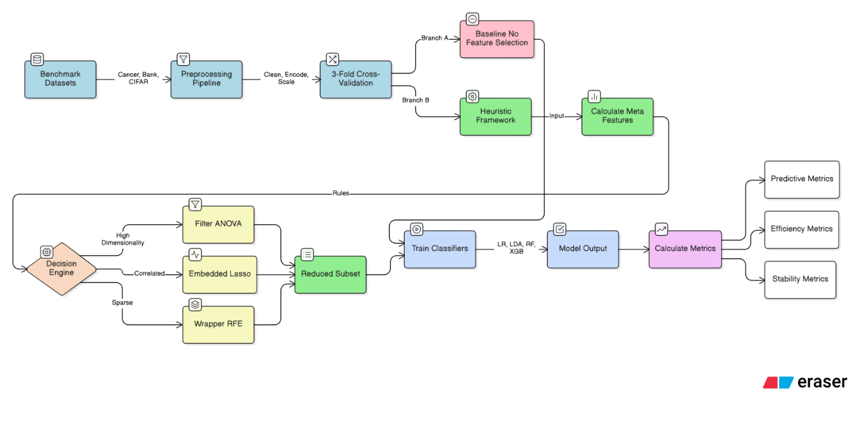
Figure 3.1 Overall Methodological Workflow (Author’s own diagram, created using Eraser.io)
Figure 3.1 summarises a controlled end-to-end pipeline designed to isolate the effect of feature selection from other modelling factors. The workflow explicitly separates (i) preprocessing and profiling, (ii) baseline modelling with the complete feature set, (iii) heuristic-driven FS decision-making, and (iv) evaluation under the same validation protocol. Critically, feature selection is performed within each training fold during cross-validation to reduce the risk of optimistic bias from information leakage from test folds. This structure enables a fair comparison between the No-FS baseline and the heuristic-FS condition, where any observed change in performance or runtime can be attributed primarily to the FS decision and the reduced subset rather than differences in preprocessing or model tuning.
1. Dataset Preparation
Benchmark datasets from healthcare, finance, and computer vision were selected to cover a range of dimensionalities and feature modalities. Each dataset was prepared using a consistent preprocessing pipeline to ensure compatibility with feature-selection and classification tasks. Detailed preprocessing procedures included handling missing values, categorical encoding, feature scaling, class balancing, and specific transformations of CIFAR-10 image data.
2. Baseline Model Development
A set of linear and non-linear classifiers was selected to establish a baseline predictive performance before applying feature selection. These models provide a quantitative reference against which the improvements (or trade-offs) arising from the heuristic-driven FS recommendations can be measured.
3. Implementation of the Heuristic Framework
The heuristic decision engine profiles each dataset using meta-features such as dimensionality ratio ($p/n$), class imbalance, correlation structure, and variance characteristics. Based on these descriptors, the framework automatically selects an appropriate FS family (Filter, Wrapper, or Embedded) and generates the corresponding reduced feature subset.
4. Comparative Evaluation and Validation
Baseline and heuristic-selected feature subsets were evaluated using a consistent validation protocol to ensure reliability. Performance metrics included predictive Accuracy, F1-score, AUC, Runtime, and feature-stability indicators (Kuncheva Index)—statistical validation procedures employed Analysis of Variance (ANOVA) and post-hoc pairwise t-tests to verify significance.

3.3 Heuristic Framework Architecture
The proposed Heuristic-Adaptive Feature-Selection Framework provides a lightweight and interpretable alternative to computationally intensive meta-learning pipelines. Instead of relying on opaque model-driven optimisation, the framework applies explicit, rule-based heuristics derived from empirical observations. These rules guide the selection of an appropriate Feature Selection (FS) family: Filter, Wrapper, or Embedded, based on dataset-level statistical characteristics.

3.3.1 Overview of the Framework
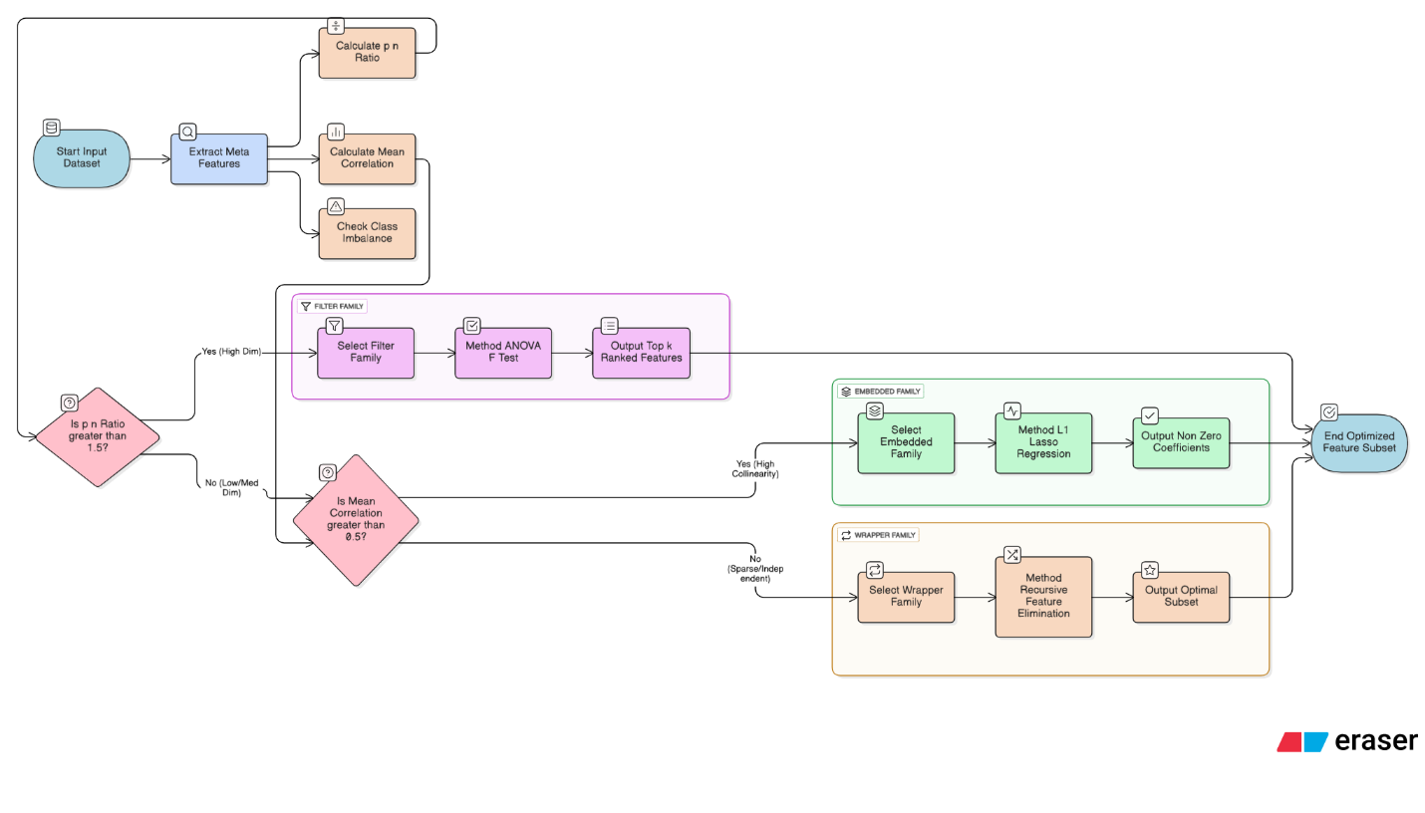
Figure 3.2 Heuristic Internal Architecture (Author’s own diagram, created using Eraser.io)
Figure 3.2 clarifies how the framework translates dataset characteristics into an FS action. The Dataset Profiler produces a compact statistical summary (meta-features) that the Heuristic Decision Module uses to select an FS family and its parameters. The Feature-Selection Engine then executes the chosen method and outputs both the transformed feature matrix and metadata describing the selection. This separation of concerns improves reproducibility and interpretability: profiling is deterministic given the training fold, decision rules are explicit and auditable, and the FS engine is implemented using standard, widely-used libraries to reduce implementation ambiguity

3.3.2 Dataset Profiler
The Dataset Profiler computes dataset-level meta-features that describe dimensionality, dependence structure, signal dispersion, and class distribution. These meta-features are calculated during model preparation and are used as transparent triggers for the heuristic rules. To minimise bias, profiling is performed on the training split (or training fold) only, mirroring how the data would be available in a real deployment pipeline.
The profiler extracts the following descriptors:
- Dimensionality ratio (p/n): computed as the number of input features p divided by the number of samples n. This provides a direct indicator of whether the task is in a low-dimensional regime (p ≪ n), a balanced regime, or a high-dimensional regime where feature selection is typically necessary to control overfitting risk and computational cost (Bellman, 1961; Guyon and Elisseeff, 2003).
- Class imbalance level: computed from the empirical class proportions, summarised as the maximum class share (majority proportion). This statistic is used to flag datasets where accuracy may be misleading, motivating the inclusion of F1-score and AUC in evaluation (Khaire and Dhanalakshmi, 2022).
- Mean absolute correlation: computed over numeric predictors as the mean of |r| across non-diagonal pairs in the correlation matrix. This summarises the strength of multicollinearity, which is known to destabilise coefficient estimates in linear models and to inflate redundancy among predictors (Guyon and Elisseeff, 2003).
- Variance structure: computed as the average per-feature variance. Very low-variance features are more likely to be uninformative and can impair learning, while extremely high variance may indicate dominant predictors that require careful handling.
- Sparsity: computed as the fraction of zero entries in the design matrix (particularly relevant after one-hot encoding). High sparsity is typical of encoded categorical datasets and may affect wrapper behaviour, because many features contribute weakly and only in specific subgroups.
- Pixel-intensity dispersion (CIFAR-10 tabular): computed through variance/dispersion summaries after flattening images to reflect whether the informative signal is concentrated in a small subset of pixel dimensions.

Table 3.1 Dataset Profile Attributes
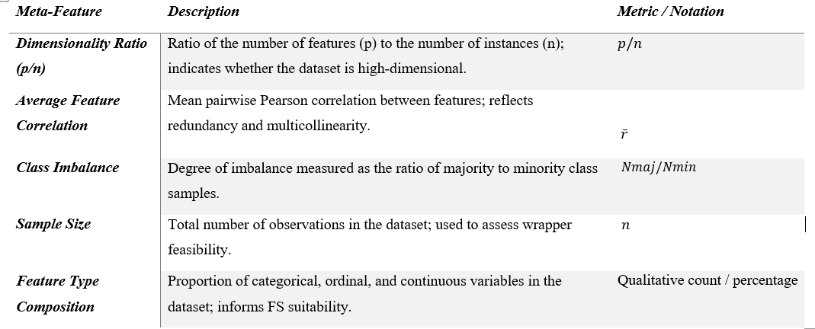

Table 3.1 defines the exact profiler outputs that drive the framework’s decisions. In practice, these attributes ensure that the heuristic is not “guessing” methods, but is responding to measurable properties of the dataset: p/n captures the feasibility of search-based selection, mean absolute correlation operationalises redundancy risk, and sparsity captures the structural effect of encoding on the feature space. Collectively, the profiler provides a reproducible and auditable basis for method selection, enabling the study to evaluate whether a small set of transparent indicators can approximate more complex automated selection systems while remaining computationally light.

3.3.3 Heuristic Decision Module
The Heuristic Decision Module maps meta-features to an FS family using explicit if–then rules. This design prioritises transparency and reproducibility, offering a lightweight alternative to “black-box” AutoML approaches. The rules were designed to reflect well-established trade-offs: filters scale to high-dimensional problems, wrappers can capture feature interactions but are expensive, and embedded methods balance predictive performance and efficiency by selecting features during model training (Guyon and Elisseeff, 2003; Kohavi and John, 1997; Bommert et al., 2022).
Key Logic Examples:
- High-dimensionality (p/n > 1.5) → Filter methods (e.g., ANOVA F-test).
The core motivation is feasibility and scalability. When the number of predictors exceeds the number of observations, model variance and search complexity increase sharply, and wrapper methods become impractical due to repeated model fitting (Bellman, 1961; Kohavi and John, 1997). The threshold is set above the basic p > n boundary to create a conservative buffer that activates filter-based reduction before entering an extreme “p≫n” regime. This aligns with high-dimensional practice where filters are commonly benchmarked as scalable defaults, particularly when thousands of features must be screened efficiently (Bommert et al., 2022).
- Strong multicollinearity (mean |r| ≥ 0.8) → Embedded methods (e.g., L1-regularised logistic regression).
When predictors are strongly correlated, feature redundancy increases and coefficient estimates become unstable in linear learners. An embedded L1 penalty shrinks irrelevant or redundant coefficients towards zero during model fitting, offering a parsimonious subset with minimal additional search cost (Tibshirani, 1996; Guyon and Elisseeff, 2003). A correlation magnitude around 0.8 is widely used as a practical indicator of severe multicollinearity in applied modelling guidance, motivating its adoption as a rule trigger.
- Low-correlation / sparse encoded space → Wrapper methods (e.g., RFE).
In sparse, weakly correlated spaces, individual features may show limited univariate relevance, but interactions can still be predictive. Wrapper methods can explore feature subsets under a classifier objective, making them suitable when dimensionality is not extreme, and interactions are expected (Kohavi and John, 1997). However, because wrappers are computationally costly, they are reserved for cases where the profiler indicates moderate feature dimensionality and where a targeted search is feasible
Table 3.2 Heuristic Decision Rules
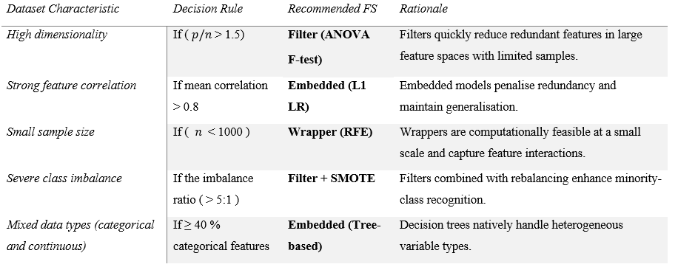
Table 3.2 formalises the mapping from profiler signals to FS actions, ensuring that the decision path is auditable. Each rule records (i) the trigger condition (e.g., p/n threshold, correlation threshold), (ii) the selected FS family, and (iii) the operational method used in implementation (e.g., SelectKBest with ANOVA, L1-logistic coefficients, or RFE). Presenting the rules in this way supports interpretability and enables replication. Given the same meta-feature profile, the framework will always choose the same FS strategy, allowing results to be attributed to a defined rule rather than hidden optimisation.

3.3.4 Feature-Selection Engine
Once an FS family is selected, the Feature-Selection Engine executes the corresponding algorithm using standard scikit-learn components. The engine is responsible for: (i) applying the method on the training data, (ii) producing the reduced feature matrix, and (iii) returning structured metadata for reporting and reproducibility (selected features, subset size, and FS runtime).
- Filter execution (SelectKBest)
For high-dimensional settings, the framework uses univariate scoring via ANOVA F-statistics (f_classif) with SelectKBest. This approach ranks features independently by their association with the class label and retains the top-k features. Filter methods are appropriate here because they scale linearly with the number of features and avoid the repeated refitting that makes wrappers infeasible in high-dimensional contexts (Bommert et al., 2022).
Retained feature count (k): When p/n > 1.5, the framework maintains approximately 5% of features, bounded to ensure stability and feasibility (minimum 50; maximum 300). In this study, CIFAR-10 tabular uses p = 3,072, so k ≈ 0.05×3,072 ≈ 153 features, matching the intended aggressive reduction strategy.
- Embedded execution (L1-regularised logistic regression)
For correlated datasets, the engine fits an L1-regularised logistic regression model. Features are ranked by the absolute magnitude of their fitted coefficients (averaged across classes if multiclass), and the top-k are retained. This embeds selection into model training, reducing redundancy and improving interpretability by linking selected variables directly to model parameters (Tibshirani, 1996; Guyon and Elisseeff, 2003).
Retained feature count (k): In low-dimensional problems, the framework uses a conservative setting that avoids over-pruning. For Breast Cancer (p = 30), the configured lower bound yields k = 30, meaning no forced reduction is applied when the dataset is already compact and information-dense.
- Wrapper execution (Recursive Feature Elimination)
For moderate-dimensional, low-correlation spaces, the engine runs RFE using logistic regression as the base estimator. RFE iteratively fits the estimator, ranks features by importance, removes the least important features, and repeats until k remains. This can capture multivariate effects but is computationally expensive because it requires multiple model fits (Kohavi and John, 1997).
Retained feature count (k): For non-high-dimensional datasets, the engine maintains max(30, 50% of p) to balance reduction with information retention. For Bank Marketing after encoding (p ≈ 47), this yields k = 30, corresponding to a moderate decrease while keeping enough predictors to model customer behaviour.

3.3.5 Implementation and Scalability
The heuristic framework is implemented in Python as a modular pipeline. Each component can be executed independently or integrated into an end-to-end FS workflow. The lightweight, rule-based design ensures:
- Low computational overhead: No expensive meta-training phase is required.
- Interpretability: Every decision is traceable to a specific dataset property.
- Extensibility: New rules can be added without retraining the system.
This architecture makes the framework suitable for settings that require efficient, transparent FS decision-making without relying on computationally intensive optimisation techniques.

3.4 Datasets

3.4.1 Overview
Three benchmark datasets were selected to evaluate the proposed heuristic-adaptive feature-selection framework across diverse domains. The datasets span finance, healthcare, and computer vision, enabling assessment under varying levels of dimensionality, class complexity, feature structure, and data distributions. Two datasets originate from the UCI Machine Learning Repository, while the third, CIFAR-10, is a widely recognised benchmark for image classification research.

Table 3.3 Summary of Benchmark Datasets Used for Framework Evaluation
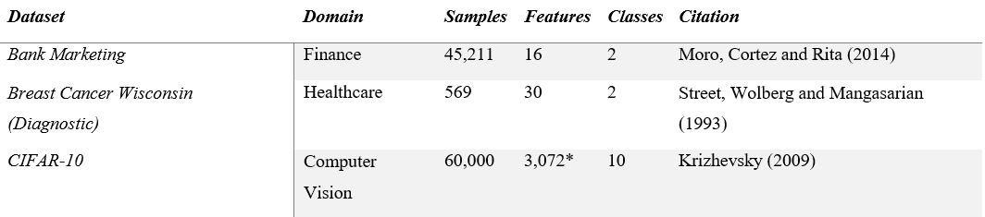
*Each image is converted into a 3,072-element feature vector by flattening 32×32×3 RGB pixels.
Table 3.3 highlights why the three datasets provide a meaningful stress test for an adaptive FS framework.
Breast Cancer represents a low-dimensional, numeric setting (small p) where the main FS objective is redundancy control and interpretability rather than computational feasibility.
Bank Marketing is a mixed-type dataset that becomes sparse after one-hot encoding, leading to a structurally different feature space where weak individual predictors and class imbalance can distort naïve optimisation objectives.
CIFAR-10 tabular represents an extremely high-dimensional (p≫n) scenario created by flattening 32×32×3 pixel values to 3,072 predictors, where runtime and overfitting risk motivate aggressive screening. These contrasting profiles ensure the heuristic is evaluated across regimes that typically favour different FS families, enabling the study to examine whether rule-based selection generalises across heterogeneous feature spaces.

3.4.2 Justification
The selection of heterogeneous datasets ensures a robust evaluation of the heuristic-adaptive framework under contrasting feature spaces:
- Bank Marketing (Finance): Contains a mix of categorical and numerical attributes with a severe class imbalance. It is used to assess how the framework manages sparse, encoded features and whether it can detect minority signals (Moro et al., 2014).
- Breast Cancer Wisconsin (Healthcare): A lower-dimensional biomedical dataset with well-studied feature intercorrelations. It supports the analysis of model interpretability, FS stability, and behaviour under tightly correlated numerical predictors (Street et al., 1993).
- CIFAR-10 (Computer Vision): Introduces a high-dimensional, image-derived feature space (3,072 continuous variables per image). Flattening pixel intensities creates a structured tabular format suitable for classical FS, challenging the framework’s scalability in a $p≫n$ Scenario (Krizhevsky, 2009).
Together, these datasets provide a comprehensive cross-domain environment that challenges the framework’s adaptability and generalisability.

3.5 Experimental Setup and Tools
The experimental configuration was designed to ensure consistency, reproducibility, and transparency across all evaluations. This section describes the computational environment, software tools, classifiers, and experimental procedures employed to benchmark traditional Feature-Selection (FS) techniques against the proposed heuristic-adaptive framework.

3.5.1 Computational Environment
All experiments were conducted on a workstation with the following specifications:
- Processor: Intel® Core™ i7 (3.40 GHz, eight cores)
- Memory: 16 GB RAM
- Operating System: Windows 11 (64-bit)
- Programming Environment: Jupyter Notebook (Anaconda Distribution, Python 3.12)
Random seeds were fixed throughout to enhance reproducibility, and execution times were measured using Python’s built-in timing utilities. This ensures that comparisons of computational efficiency across FS approaches remain fair and consistent.
Detailing the open-source Python libraries used for implementing the pipeline enhances transparency and supports reproducibility in the methodology section.
Open-source Python libraries were used to implement the whole pipeline from preprocessing through evaluation, ensuring transparency and replicability:
- Data Preprocessing: pandas, NumPy, scikit-learn, preprocessing
- Feature Selection: scikit-learn.feature_selection, mlxtend, XGBoost, and custom heuristic modules
- CIFAR-10 Handling: torchvision, Pillow, and NumPy for image loading and pixel-level vectorisation
- Classification Models: scikit-learn implementations of Logistic Regression, Linear Discriminant Analysis, Random Forest, and the XGBoost classifier
- Model Evaluation and Visualisation: matplotlib, seaborn, and SciPy for statistical analysis

3.5.3 Data Preprocessing Pipeline
Implementing a unified preprocessing pipeline with controlled dataset-specific variations ensures that differences in results are attributable to FS decisions, supporting reproducibility.
- Data ingestion and basic validation
Each dataset was loaded into a tabular representation and checked for (i) duplicated rows, (ii) invalid labels, and (iii) inconsistent datatypes. Summary checks (shape, missingness counts, and class frequencies) were recorded to support profiling and reproducibility.
- Missing-value handling
For structured datasets, missing values were treated using simple, reproducible imputations aligned with common practice in baseline ML pipelines. Numeric features used mean imputation, while categorical features used mode imputation. When missingness was excessive, rows exceeding a threshold were removed to prevent systematic distortion of the learning signal. CIFAR-10 contains no missing values.
- Categorical encoding (Bank Marketing)
Bank Marketing includes categorical fields that require encoding before model fitting. One-hot encoding was applied to convert each categorical attribute into a set of binary indicator columns, resulting in a sparse design matrix. This transformation increases dimensionality but preserves information without imposing an ordinal relationship between categories.
- Feature scaling and normalisation
Scaling was applied to ensure comparability of feature magnitudes, particularly for distance- or coefficient-based learners. For numeric tabular features, standardisation (zero mean, unit variance) was applied. For CIFAR-10, pixel intensities were normalised to [0,1] by dividing raw RGB values by 255, ensuring stable numeric ranges across models.
- CIFAR-10 tabular transformation
To enable classical FS methods, each 32×32×3 image was flattened into a 3,072-dimensional feature vector. To maintain feasibility under the available compute budget, a controlled subset of images was sampled for experiments, ensuring consistent sample size across runs while preserving class balance as far as possible.

- Train–test split and leakage control
All datasets were split using an 80/20 stratified split, preserving class proportions. During cross-validation, preprocessing transformations and FS were applied only to the training folds to reduce leakage risk, and the learned transformations were applied to the corresponding test folds.
- Class balancing (Bank Marketing only)
Because the Bank Marketing dataset is severely class-imbalanced, the Synthetic Minority Over-sampling Technique (SMOTE) was applied to the training data to generate synthetic minority-class instances and reduce bias towards the majority class (Chawla et al., 2002). To prevent data leakage and overly optimistic estimates, oversampling was performed only within the training folds/splits, leaving the validation/test folds untouched (Kuhn and Johnson, 2013). The effect of class balancing was assessed using F1-score and AUC (which are more informative than accuracy under imbalance), alongside accuracy for completeness (Saito and Rehmsmeier, 2015; He and Garcia, 2009).
- Output for modelling and FS
The final output of preprocessing is a numeric feature matrix X and label vector y, ready for (i) baseline No-FS modelling and (ii) heuristic profiling and feature selection. All preprocessing parameters and random seeds were logged for replication.

3.5.4 Linear and Non-Linear Classifiers
To evaluate the influence of feature selection, four classifiers were employed:
- Linear Models:
  - Logistic Regression (LR): Baseline linear classifier; sensitive to multicollinearity.
  - Linear Discriminant Analysis (LDA): Projects data into a lower-dimensional discriminative subspace.
- Non-Linear Models:
  - Random Forest (RF): Captures non-linear interactions; provides embedded feature importance.
  - XGBoost: A gradient-boosted model known for strong performance on tabular data.
Minimal tuning was applied, and default parameters were retained unless required for convergence.
Table 3.4 Summary of Classifiers and Parameters
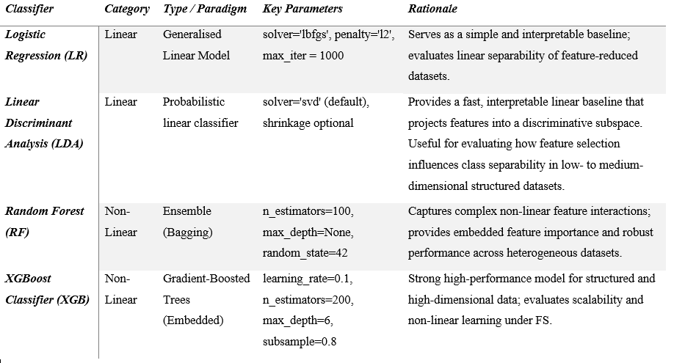
Table 3.4 shows that the evaluation uses two linear models (LR, LDA) and two non-linear models (RF, XGBoost) to test whether heuristic-driven FS is beneficial across different modelling assumptions. The selected configuration avoids extensive hyperparameter optimisation, so that performance differences can be attributed primarily to the presence or absence of feature selection rather than to tuning. Minor parameter adjustments were applied only where needed for reliable execution and comparability, notably increasing LR’s max_iter to support convergence in higher-dimensional/sparser settings and fixing random seeds for RF/XGBoost to improve reproducibility. This design promotes fair baseline comparisons and helps expose dataset-dependent trade-offs between accuracy, runtime, and stability under both linear and interaction-capable learners.

3.5.5 Baseline vs. Heuristic Configuration
Two experimental configurations were evaluated:
- Baseline (No-FS): Classifiers trained directly on the complete feature set (including the 3,072-dimensional CIFAR vectors).
- Heuristic-FS: The heuristic framework selected an FS family (Filter, Wrapper, or Embedded) based on meta-features, produced a reduced subset, and classifiers were trained on this subset.
Holding hyperparameters and data partitions constant ensures that any performance differences reflect the contribution of FS rather than model tuning

3.6 Performance Evaluation and Validation
This evaluation strategy, combining multiple metrics and statistical validation, aims to ensure the robustness and credibility of the findings for all involved researchers and data scientists.

3.6.1 Evaluation Objective
The performance assessment aimed to:
- Quantify the predictive capability of each FS method using multiple classification models.
- Compare the computational efficiency (runtime and resource usage) across FS families.
- Evaluate the stability of feature subsets generated under repeated sampling.
- Statistically validate whether observed performance differences are significant.
Together, these criteria test the study’s hypothesis that a lightweight heuristic-driven framework can achieve an optimal trade-off between predictive accuracy and computational cost.

3.6.2 Performance Metrics
Performance was assessed through a combination of classification quality, efficiency, and stability indicators. All metrics were calculated using the testing folds of each cross-validation run.

Table 3.5 Performance Metrics
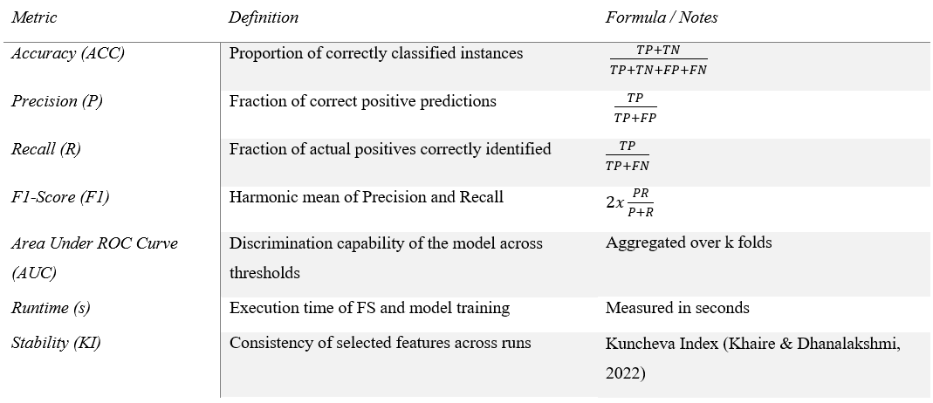
Table 3.5 combines predictive, efficiency, and robustness criteria to reflect the dissertation’s aim of balancing accuracy, runtime, and stability. Accuracy is retained for interpretability, but the evaluation prioritises F1-score and AUC where class imbalance and probability calibration are essential, ensuring that improvements are not superficial. Runtime is treated as a first-class outcome because one motivation for heuristic FS is reducing computation without requiring expensive search procedures. Finally, stability (as measured by the Kuncheva Index) addresses a common weakness of FS methods. If different folds repeatedly select very different subsets, then the FS process may be unreliable and harder to justify in applied domains. Together, these metrics enable a more complete assessment than predictive performance alone, aligning directly with the framework’s “lightweight, interpretable, and efficient” design objective.
Feature Stability (Kuncheva Index): The Kuncheva Index (KI) measures the consistency of feature subsets selected across different cross-validation folds. It corrects the Jaccard index for chance agreement:
$$KI\left(A,B\right)=\frac{r∙N-k^{2}}{(k∙(N-k))}$$
Where $r$ Is the size of the intersection between two subsets, $N$ Is the total number of features in the dataset, and $k$ Is the subset size. A higher $KI$(closer to 1.0) indicates greater robustness and reproducibility of the FS process (Khaire & Dhanalakshmi, 2022).

3.6.3 Validation Procedure
To ensure statistical reliability and robustness, a two-level validation scheme was applied.
A) K-Fold Cross-Validation: A 3-fold cross-validation procedure was used for each dataset and classifier configuration:
- The dataset was partitioned into three stratified folds.
- In each iteration, two folds were used for training (including the FS step) and one fold for testing.
- FS was performed only on the training fold to avoid data leakage (biasing the selection with test data).
- Performance metrics were averaged across the three folds.
This approach provides robust estimates of model generalisability while keeping computational costs manageable for wrapper methods.
B) Repeated-Seed Validation: To further reduce stochastic variability, all experiments were repeated using two different random seeds (Total = 6 evaluations per configuration):
- Different seeds affect cross-validation splits, SMOTE resampling, and model initialisation.
- Averaging across seeds improves the reliability of comparative analysis.
- Variance across seeds is reported to indicate the sensitivity of FS methods to random perturbations.
This repeated-seed strategy strengthens reproducibility and aligns with rigorous evidence standards.

3.6.4 Statistical Analysis
Inferential statistics complemented quantitative comparisons to determine whether differences among FS strategies were statistically significant:
- Analysis of Variance (ANOVA): Conducted to compare mean performance (e.g., accuracy, F1, runtime) across multiple FS methods within each dataset.
- Post-hoc Pairwise Tests: Where ANOVA indicated significant differences (p < 0.05), pairwise t-tests were applied to identify specific method pairs exhibiting significant divergence.
All tests were conducted at the 95 % confidence level, following guidelines for reproducible machine learning evaluation (Bommert et al., 2022).

3.6.5 Validation of the Heuristic Framework
The heuristic-adaptive framework was evaluated under identical conditions to the baseline FS methods. The recommended FS strategy for each dataset was automatically selected by the decision rules defined in Section 3.3.
The comparative analysis focused on three key outcomes:
- Predictive Gain: Improvement (or parity) in F1 and AUC relative to the No-FS baseline.
- Efficiency Gain: Reduction in average runtime compared with computationally expensive wrapper methods.
- Stability: Consistency of selected features across folds ($KI>0.5$), reflecting robustness to sampling variability.
Positive outcomes across these indicators validate the framework’s ability to balance performance and interpretability without relying on computationally intensive optimisation.

3.6.6 Reproducibility and Transparency
All code, parameter settings, and random seeds were documented to ensure reproducibility. Experiments were logged using version-controlled Jupyter notebooks, and performance results were stored in CSV format for further statistical analysis. This transparent evaluation process supports the scientific integrity of the findings and facilitates replication by other researchers.

3.7 Ethical Considerations
Although all datasets used in this study are publicly available and anonymised, several ethical considerations were addressed to ensure responsible and transparent research practice.
- Data Privacy and Responsible Use
Only openly released and fully de-identified datasets were used, minimising privacy risks and ensuring compliance with standard data protection principles (Dua and Graff, 2019). No attempt was made to re-identify individuals, and all data handling followed established ethical norms for secondary data analysis.
- Algorithmic Fairness and Bias Mitigation
Feature-selection processes can unintentionally amplify biases present in the underlying data by discarding features that protect minority groups. To address this, selected features and model outputs were inspected for potential discriminatory patterns, particularly within the Healthcare and Bank Marketing datasets, where biased predictions can lead to harmful outcomes (Obermeyer and Emanuel, 2016). The inclusion of model-agnostic interpretability tools, such as SHAP, supports fairness auditing by enabling visibility into how individual features influence predictions.
- Transparency, Reproducibility, and Open Science
All preprocessing steps, FS procedures, classifier configurations, and evaluation metrics were documented and executed using version-controlled Jupyter notebooks. Code and experimental logs will be archived in a public GitHub repository to support full reproducibility and external validation of the findings. This aligns with the principles of transparent and responsible AI research.
- Interpretability and Explainable Decision-Making
Because feature selection influences downstream decision-making, particularly in sensitive domains such as healthcare and finance, the study prioritised model interpretability. The heuristic framework relies on explicit, rule-based logic rather than "black-box" optimisation, ensuring that FS recommendations are understandable and audit-ready. This design aligns with recent calls for interpretable machine-learning systems that enable human oversight and accountability (Doshi-Velez and Kim, 2017).

3.8 Project Timeline
The project followed a structured timeline to ensure systematic execution of dataset preparation, framework development, experimentation, and dissertation writing. Table 3.6 presents the high-level schedule from project initiation to the completion of the final report. Activities were conducted iteratively, allowing refinement of the heuristic rules and experimental procedures based on emerging results.
Table 3.6 Project Timeline Grant Chart
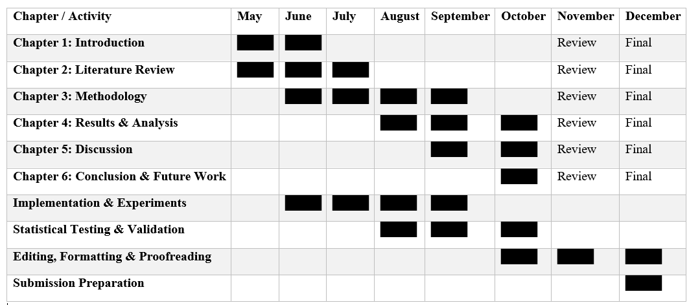

3.9 Summary
This chapter presented the methodological foundation of the study, detailing the research design, dataset preparation procedures, experimental setup, and the architecture of the Heuristic-Adaptive Feature-Selection Framework.
The evaluation strategy, incorporating 3-fold cross-validation, repeated-seed testing, performance metrics, stability analysis (Kuncheva Index), and statistical validation, was described in detail to ensure methodological rigour and reproducibility. Furthermore, ethical considerations regarding data privacy and bias, along with a structured project timeline, were provided to support transparency and responsible research practice.
Together, these components establish a robust empirical foundation for assessing the effectiveness and efficiency of the proposed framework. The next chapter (Chapter 4: Results and Analysis) reports the experimental findings and presents a comparative evaluation of the heuristic-selected feature subsets against the baseline methods.

Results and Analysis

4.1 Introduction
This chapter presents the empirical results of the heuristic-adaptive Feature-Selection (FS) framework introduced in Chapter 3. The analysis evaluates whether a lightweight, rule-based decision mechanism can enhance predictive performance, improve computational efficiency, and maintain stability across diverse datasets. Three benchmark datasets, Breast Cancer Wisconsin (healthcare), Bank Marketing (finance), and a tabular subset of CIFAR-10 (computer vision), were selected to represent contrasting levels of dimensionality, correlation structure, and class imbalance.
All experiments followed the unified preprocessing pipeline outlined in Chapter 3 and employed identical train–test partitions to ensure comparability across FS conditions. Performance was assessed using six repeated cross-validation runs per configuration. The evaluation metrics include Accuracy, F1-score, Area Under the ROC Curve (AUC), FS Runtime, Classifier Training Time, and Stability (measured using the Kuncheva Index). Both linear (Logistic Regression, LDA) and non-linear (Random Forest, XGBoost) models were evaluated to determine how FS interacts with different learning paradigms.
The chapter proceeds as follows:
- Section 4.2 introduces dataset characteristics and class-distribution patterns.
- Section 4.3 reports baseline (No-FS) results.
- Section 4.4 details the heuristic decision logic and selected FS families.
- Sections 4.5 & 4.6 evaluate empirical performance and runtime efficiency.
- Section 4.7 analyses feature stability using the Kuncheva Index.
- Section 4.8 presents statistical significance testing (ANOVA and t-tests).
- Section 4.9 examines model interpretability using SHAP values.
- Section 4.10 summarises the key findings and trade-offs.
The findings collectively assess whether the heuristic-adaptive strategy provides a practical balance between performance, efficiency, and interpretability in automated machine learning pipelines.

4.2 Dataset Exploration and Characteristics
Understanding the dataset structure is essential for interpreting FS behaviour, as dimensionality, correlation, and class distribution directly influence which FS family the heuristic engine selects and how the resulting feature subset affects predictive performance (Bolón-Canedo et al., 2015; Li et al., 2017). This section provides an overview of dataset metadata and explores class distributions, highlighting conditions likely to affect downstream modelling.

4.2.1 Summary of Dataset Properties
Table 4.1 summarises the core structural properties of the three benchmark datasets used in this study: sample size (n), number of features (p), number of classes, and the p/n ratio (features-to-samples). These properties are not just descriptive; they are the primary inputs to the heuristic decision engine because they strongly affect (i) overfitting risk, (ii) computational cost, and (iii) the likely suitability of filter, wrapper, or embedded feature selection (FS) families.
Table 4.1 Summary of Dataset Characteristics
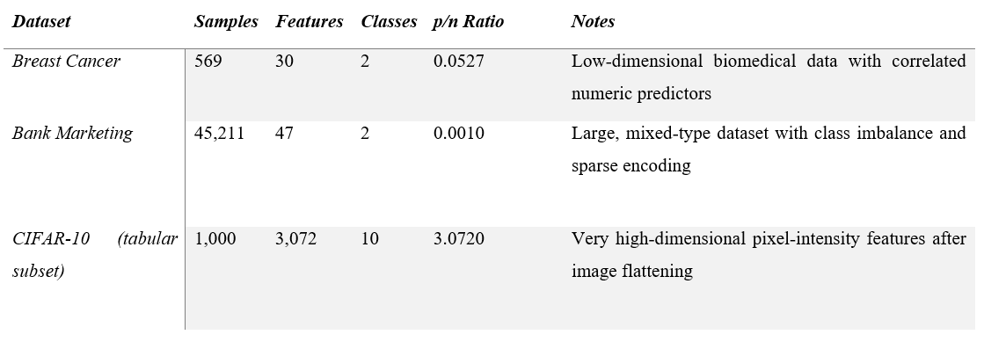
These datasets create a deliberately heterogeneous test environment, allowing the framework to be evaluated across contrasting conditions low-dimensional biomedical prediction (where FS mainly supports interpretability and minor efficiency gains), moderately dimensional tabular classification (where redundancy and imbalance can affect minority-class performance), and large, sparse, high-dimensional vision-derived data (where aggressive dimensionality reduction is needed to control runtime and overfitting).

4.2.2 Datasets Class Distribution Analysis

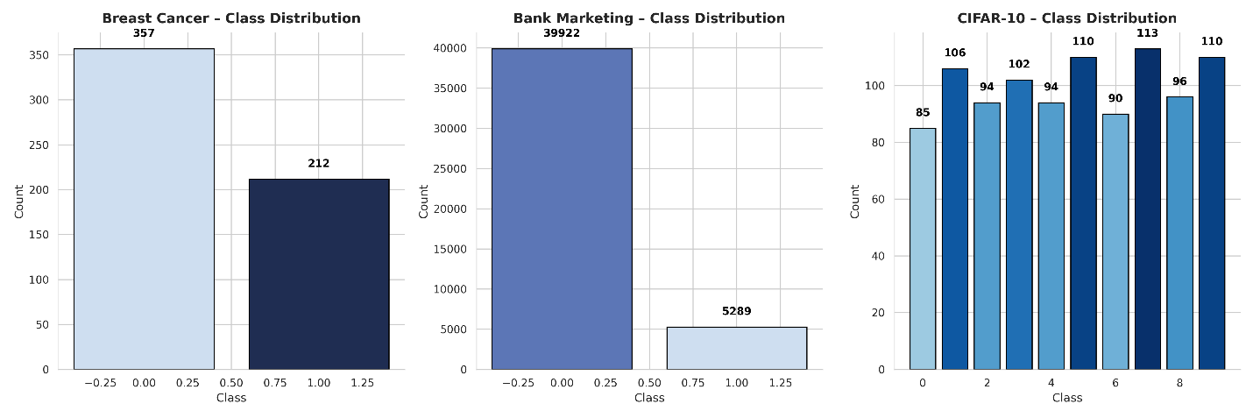
Figure 4.1 Target-Class Distribution Across the Three Benchmark Datasets (Breast Cancer, Bank Marketing, CIFAR-10)
Figure 4.1 visualises the target-class distribution across the three datasets, highlighting an apparent imbalance that can affect both model learning and feature selection. In imbalanced settings, classifiers may lean towards the majority class, inflating accuracy while reducing detection of the minority class. This is why later comparisons in this chapter place greater emphasis on F1-score and AUC (especially for Bank Marketing), rather than accuracy alone.
- Breast Cancer contains 357 benign and 212 malignant cases, indicating a moderate imbalance. This level of skew is standard in screening datasets and is usually manageable, but it can still affect sensitivity to malignant cases if left unmonitored. In this study, performance on this dataset is evaluated using minority-aware metrics (F1 and AUC) alongside accuracy. At the same time, FS is expected to make more minor, more stability/interpretability-driven improvements rather than dramatic performance shifts.
- Bank Marketing shows a severe imbalance (≈39,922 “no” vs 5,289 “yes”). This skew can distort decision boundaries and increase the risk that FS, particularly wrapper approaches like RFE, selects features that primarily explain the majority class. To reduce this effect, SMOTE was applied within the training folds only during cross-validation, ensuring the minority class was better represented during learning without leaking information into the test folds. This choice also aligns with the heuristic goal of maintaining minority-class discrimination, so subsequent results for Bank Marketing are mainly interpreted using F1-score and AUC, where any loss in minority-class performance becomes apparent.
- CIFAR-10 is approximately class-balanced across its ten categories (around 90–113 samples per class). This balance is helpful because it removes imbalance as a confounding factor, allowing later performance and runtime changes to be more confidently attributed to dimensionality and heuristic-driven FS choices (e.g., filter selection under high p/n) rather than to majority-class dominance.
Overall, Figure 4.1 supports the need for dataset profiling in the heuristic framework: alongside p/n, the level of class imbalance helps determine both (i) the preprocessing strategy (e.g., SMOTE for Bank Marketing) and (ii) the most appropriate evaluation focus (F1/AUC emphasis under imbalance), which then frames how FS outcomes are judged in the results tables and figures that follow.

4.3 Baseline Model Performance (No Feature Selection)
Baseline experiments were conducted using all available features for each dataset and classifier, establishing a consistent no-FS reference point for evaluating the effect of heuristic feature selection. This baseline reflects model behaviour under the raw dimensionality of each dataset, including redundancy and noise.
Table 4.2 Baseline Performance Across All Datasets (No-FS Condition)
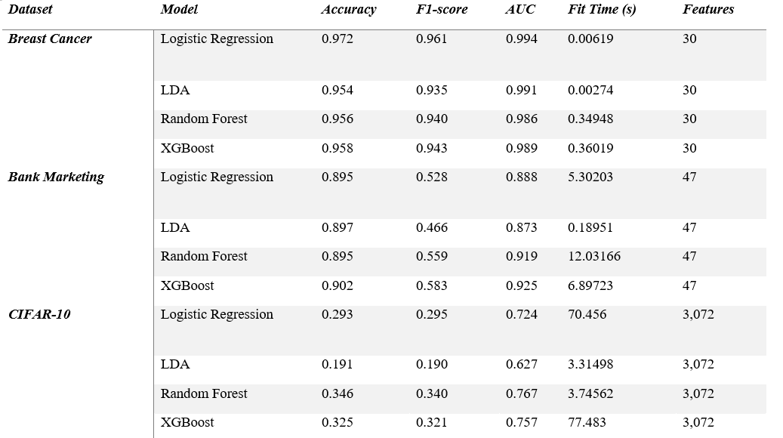
Table 4.2 reports the mean performance across six repeated cross-validation runs (3-fold CV repeated over multiple random seeds), summarising accuracy, F1-score, AUC, and runtime. Accuracy provides an overall correctness measure, while F1-score and AUC better reflect minority-class sensitivity when imbalance is present (especially in Bank Marketing). Runtime captures the computational burden of training and evaluation with complete feature sets, which is expected to be most demanding under very high dimensionality (e.g., CIFAR-10).
Interpretation (Table 4.2)
For Breast Cancer, baseline performance is consistently strong across models, reflecting the dataset’s low dimensionality and clear diagnostic signal; any gains from heuristic FS are therefore expected to relate more to efficiency and interpretability than considerable accuracy improvements. For Bank Marketing, accuracy alone appears favourable for some models, but F1 and AUC show the impact of severe class imbalance and the difficulty of detecting the minority “yes” class; this motivates the later focus on F1/AUC when comparing heuristic FS to the baseline. For CIFAR-10, baseline accuracy is limited by pixel-level noise and the absence of spatial structure in tabular form, while runtime is substantially higher due to the 3,072-dimensional feature space; this directly supports the need for dimensionality reduction and explains why the heuristic rules prioritise lightweight filter-based FS under high p/n.

4.3.2 Implications for Feature Selection
The baseline results reinforce several vital motivations for applying the heuristic framework:
- Efficiency: The high dimensionality in CIFAR-10 significantly increases runtime without yielding proportional accuracy gains, establishing a clear need for aggressive dimensionality reduction (Filter methods).
- Complexity: The Bank dataset’s imbalance and sparsity weaken linear classifiers, suggesting that method selection must account for more than just dimensionality (Wrapper methods).
- Stability: While Breast Cancer accuracy is high, the aim of FS here is to remove redundancy without harming the already-strong performance (Embedded methods).
These observations provide the foundation for evaluating whether the heuristic framework can improve efficiency while maintaining (or enhancing) predictive power in the subsequent sections.

4.4 Heuristic Feature-Selection Behaviour
The heuristic-adaptive framework successfully automated the selection of a Feature Selection (FS) family for each dataset using the meta-features defined in Chapter 3 (dimensionality, mean absolute correlation, and class imbalance). The decision module triggered specific rules based on these characteristics, resulting in the distinct FS configurations detailed in Table 4.3.
Table 4.3 Heuristic FS Decisions and Triggered Rules
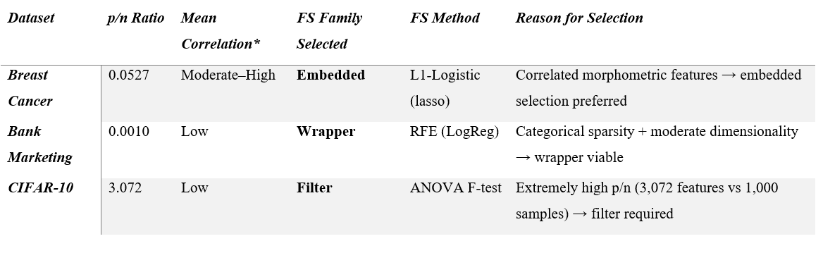
*Correlation computed from numeric subset of features only
The decisions align precisely with the design principles of the heuristic framework:
- High-dimensional datasets (p/n > 1.5): Trigger scalable Filter methods (e.g., CIFAR-10)
- Datasets with strong multicollinearity: Trigger Embedded methods to leverage regularisation (e.g., Breast Cancer).
- Moderate dimensionality ( p/n < 1.5 ) & low collinearity: Trigger Wrapper methods to search for interactions (e.g., Bank Marketing)

These choices replicate patterns reported in recent FS benchmarking studies (Bommert et al., 2022), verifying that the heuristic logic is consistent with established theory.

4.4.1 Cross-Dataset Behavioural Observations
- Breast Cancer (Low-dimensional, Correlated)
Breast Cancer contains 30 numeric features with several moderately correlated pairs. This characteristics profile triggered the Embedded-method rule, selecting L1-regularised Logistic Regression. Theoretically, Embedded FS is optimal here due to its coefficient-based interpretability and ability to handle redundant morphometric features without the computational cost of wrappers.
- Bank Marketing (Mixed-type, Sparse)
The Bank dataset’s 47 features are primarily the result of one-hot encoding, leading to high sparsity and low feature–feature correlation. These characteristics activated the Wrapper rule, selecting Recursive Feature Elimination (RFE). The heuristic premise is that in sparse spaces, individual predictors are weak, and iterative wrapper searches are required to identify multivariate interactions.
- CIFAR-10 (High-dimensional)
With 3,072 features, CIFAR-10 represents a classic $p≫n$ Scenario. The High-dimensionality rule triggered the selection of Filter FS (ANOVA F-test). This decision prioritises computational feasibility, aggressively reducing the feature space to prevent the exponential runtime growth associated with wrapper methods on pixel data.

4.4.2 FS Output Summary
Table 4.4 reports the final number of features retained by the heuristic for each dataset, showing how the framework adjusts the strength of reduction (k) based on dataset profiling signals such as dimensionality (p/n) and the expected risk of overfitting or computational burden. Rather than applying a fixed percentage across all datasets, the heuristic varies the reduction level to balance information retention against runtime and stability considerations.
Table 4.4 Features Before and After Heuristic FS
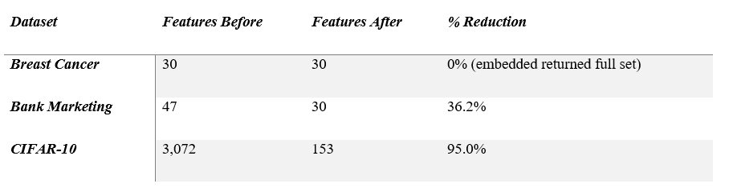
The heuristic demonstrated adaptive behaviour:
- Conservative (Breast Cancer, 0% reduction):
For Breast Cancer, the heuristic avoided unnecessary reduction and retained all features. This behaviour is appropriate in a low-dimensional, information-dense dataset, where aggressive FS is more likely to remove useful diagnostic variables than to improve generalisation. In this case, the heuristic’s value lies in confirming that the complete feature set is already compact and adequate, rather than forcing a reduction for its own sake.
- Targeted (Bank Marketing, 36% reduction):
For Bank Marketing, the heuristic applied a moderate reduction intended to remove redundant or weak predictors while preserving enough variables to maintain predictive signal. This outcome reflects a “middle-ground” setting where dimensionality is not extreme, but the dataset includes mixed feature types and potential sparsity from encoding. The reduction level indicates an attempt to improve efficiency and reduce noise without collapsing the representation. However, later performance results suggest that minority-class detection must still be closely monitored in this imbalanced dataset.
- Aggressive (CIFAR-10, 95% reduction):
For CIFAR-10, the heuristic enforced a substantial feature cut to make learning feasible under very high dimensionality. Reducing from thousands of pixel features to a small subset is consistent with the high p/n rule, where wrapper methods become impractical and even embedded approaches can be expensive. The scale of reduction demonstrates that the heuristic is capable of producing computationally tractable subsets in extreme settings,

4.5 Performance Comparison After Heuristic FS
This section evaluates the performance of the heuristic-selected feature subsets across the Breast Cancer, Bank Marketing, and CIFAR-10 datasets. Results are compared directly against the baseline (No-FS) condition using six repeated cross-validation runs. Performance is assessed using Accuracy, F1-score, and AUC, which together capture overall correctness, minority-class sensitivity, and threshold-independent ranking quality. Figures 4.2–4.4 present side-by-side comparisons of No-FS vs Heuristic-FS for each classifier.
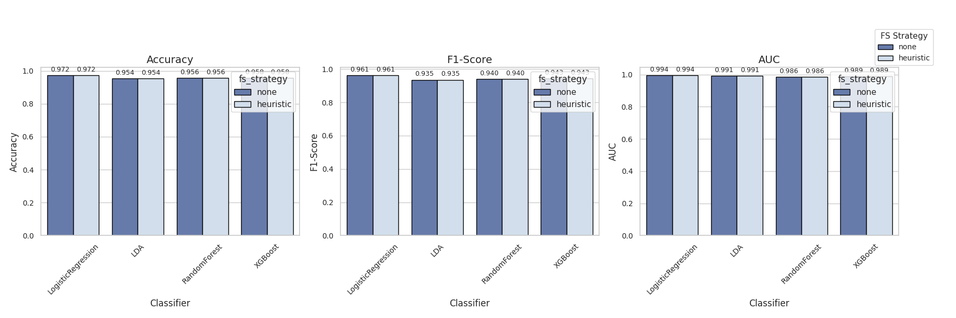
Figure 4.2: Breast Cancer – No-FS vs Heuristic-FS
Figure 4.2 shows that heuristic FS produced no measurable change in Accuracy, F1-score, or AUC across all four classifiers for the breast cancer dataset. For example, Logistic Regression remains at Accuracy = 0.972, F1 = 0.961, and AUC = 0.994 under both conditions, with similarly stable values for LDA, Random Forest, and XGBoost. This pattern is consistent with the dataset profile: Breast Cancer is low-dimensional (p=30) and contains a strong diagnostic signal, indicating that most features already provide helpful information. The heuristic’s conservative behaviour is therefore appropriate: rather than forcing reduction, it effectively preserves predictive performance while avoiding the removal of informative variables. In practical terms, this outcome suggests that for compact biomedical datasets, the heuristic framework is more likely to support interpretability and stability than to deliver significant accuracy gains.
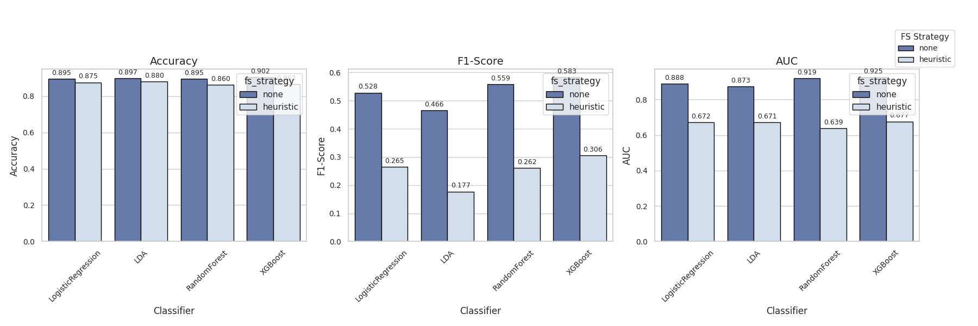
Figure 4.3 Bank Marketing – No-FS vs Heuristic-FS
Figure 4.3 reveals a clear divergence between Accuracy and the minority-sensitive metrics after heuristic FS. Accuracy drops only slightly (e.g., Logistic Regression 0.895 → 0.875; Random Forest 0.895 → 0.860), but F1-score collapses sharply across all models for the bank marketing dataset (e.g., Logistic Regression 0.528 → 0.265, LDA 0.466 → 0.177, Random Forest 0.559 → 0.262, XGBoost 0.583 → 0.306). The AUC values also fall substantially (e.g., Random Forest 0.919 → 0.639), indicating a meaningful loss in discrimination capacity rather than a minor threshold effect. This behaviour is strongly linked to the dataset’s severe class imbalance: even with SMOTE applied within training folds, an aggressive subset selection can remove “weak but necessary” features that help distinguish the minority “yes” class. In heuristic terms, this suggests that the chosen strategy (wrapper/RFE) did not preserve minority-class signal and may have prioritised features that mainly separate the majority class. Therefore, for imbalanced tabular datasets, the figures indicate that F1-score and AUC should be treated as the primary success criteria, and that heuristic rules may require additional safeguards (e.g., imbalance-aware selection objectives or minimum recall constraints).
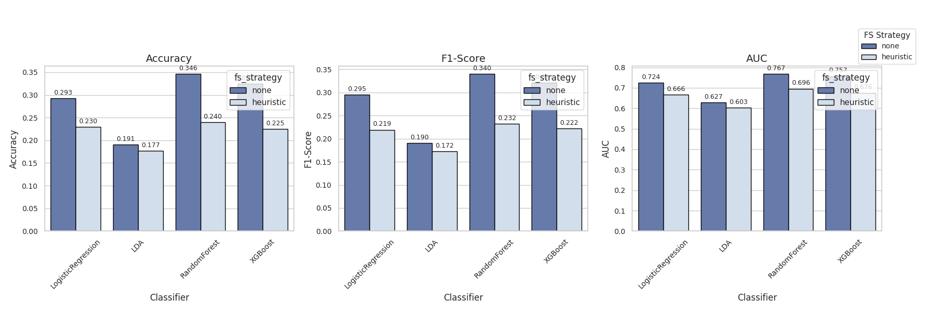
Figure 4.4 CIFAR-10 – No-FS vs Heuristic-FS
Figure 4.4 shows that heuristic FS leads to a consistent decrease in predictive performance across models, alongside the expected efficiency benefits for the CIFAR dataset. Accuracy falls for every classifier (e.g., Logistic Regression 0.293 → 0.230, Random Forest 0.346 → 0.240, XGBoost 0.325 → 0.225), and the same decline is reflected in F1-score (e.g., Random Forest 0.340 → 0.232) and AUC (e.g., Random Forest 0.767 → 0.696). This outcome is consistent with the dataset characteristics: CIFAR-10 in tabular pixel form is very high-dimensional (p = 3,072), and univariate filter methods can remove large portions of the feature space without capturing spatial or interaction structure that supports image recognition. In other words, the heuristic achieves the intended dimensionality reduction, but the figures show that the trade-off is a meaningful loss in predictive signal. This supports a key interpretation for the framework: filter-based FS is effective for making high-dimensional data computationally manageable, but it may be too aggressive for complex perceptual tasks unless combined with stronger representations or feature grouping.

4.6 Runtime and Efficiency Analysis
Runtime is a critical evaluation dimension for Feature Selection (FS), particularly in high-dimensional tasks where the computational burden can exceed the gains in predictive performance (Bommert et al., 2022). This section examines the total runtime for each classifier under the No-FS and Heuristic-FS conditions. Total runtime is defined as the sum of the feature selection calculation time and the model fitting time. $(T_{total}=T_{FS }+ T_{fit }$), averaged across six evaluation runs.
The results demonstrate that runtime behaviour differs substantially across datasets, driven by the interaction between data dimensionality. $(p)$The chosen FS strategy (Wrapper vs. Filter vs. Embedded) and classifier complexity.

4.6.1 Runtime Results for Bank Marketing Datasets
The Bank Marketing dataset shows the most severe computational penalty under the heuristic framework. As shown in Figure 4.5 below, total runtime increases substantially for all classifiers when heuristic FS is applied. For example, Logistic Regression increases from 5.30s to 27.90s (~5.3×), Random Forest from 12.03s to 26.51s (~2.2×), and XGBoost from 6.90s to 37.20s (~5.4×). The most extreme case is LDA, which rises from 0.19s to 23.48s (over 100×), indicating that the added FS step dominates the overall pipeline cost.
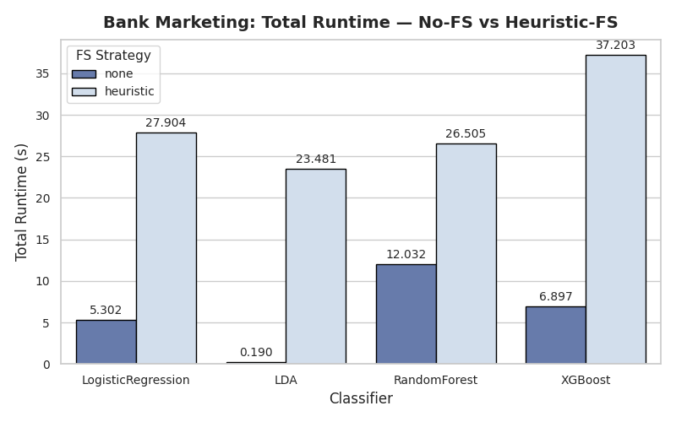
Figure 4.5 Bank Marketing Total Runtime
Interpretation: This dramatic increase aligns with the heuristic’s choice of a wrapper strategy (RFE) for this dataset. Wrapper selection requires repeated model fitting while features are iteratively removed, making the runtime sensitive to both the number of candidate features and the number of elimination steps. In Bank Marketing, one-hot encoding introduces sparsity and expands the feature space, making the wrapper procedure disproportionately expensive relative to training the final classifier once.
Key insight: For medium-dimensional but sparse / one-hot encoded datasets, wrapper FS can become a computational bottleneck. Importantly, this overhead is challenging to justify here, as Section 4.5 also shows degraded minority-class performance (F1 and AUC), indicating that the heuristic did not achieve a favourable efficiency–performance balance in this setting.

4.6.2 Runtime Results for Breast Cancer
In contrast, Breast Cancer shows negligible runtime differences between the baseline and heuristic conditions as revealed in Figure 4.6 below. Total runtime remains extremely low across all classifiers: Logistic Regression increases from 0.006s to 0.014s, LDA from 0.003s to 0.012s, Random Forest from 0.349s to 0.385s, and XGBoost from 0.360s to 0.370s. Although the relative change looks noticeable for the fastest models, the absolute increase is only a few milliseconds and has no practical impact.
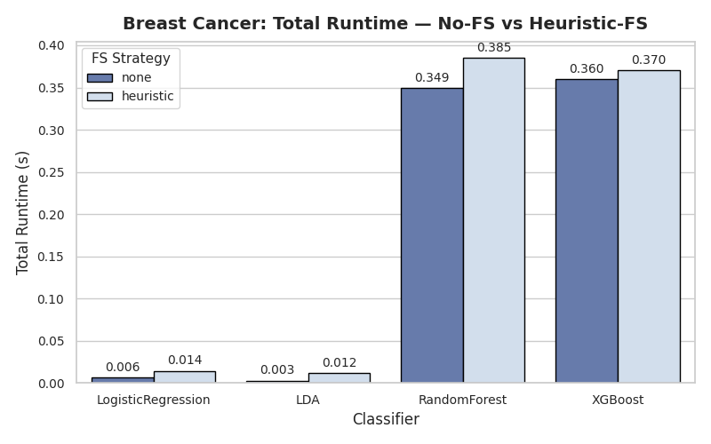
Figure 4.6 Breast Cancer Dataset Runtime
Interpretation: This stable runtime behaviour is consistent with two dataset-level factors. First, Breast Cancer is low-dimensional (p = 30), so the feature search space is small and inexpensive to process. Second, the heuristic’s selected embedded approach (L1-regularised Logistic Regression) integrates feature selection into model fitting rather than running an expensive iterative search loop, keeping overhead minimal.
Key insight: Heuristic FS is computationally “safe” for compact biomedical datasets: it introduces near-zero latency while maintaining performance, making it suitable when the goal is primarily interpretability and robust modelling rather than aggressive reduction.

4.6.3 Runtime Results for CIFAR-10
CIFAR-10 exhibits a mixed runtime pattern shown in Figure 4.7 below, where heuristic FS substantially improves efficiency for some models but increases runtime for others. Significant reductions are observed for computationally heavy learners: Logistic Regression drops from 70.46s to 18.88s (~3.7× faster) and XGBoost drops from 77.48s to 31.85s (~2.4× faster). However, runtime increases for faster learners: LDA rises from 3.32s to 11.93s (~3.6× slower) and Random Forest from 3.75s to 12.36s (~3.3× slower).
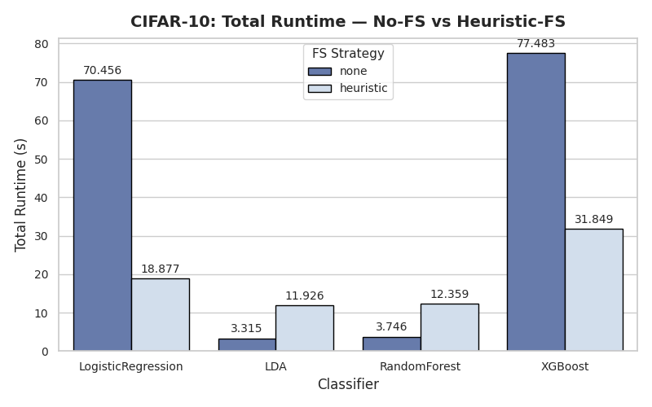
Figure 4.7 CIFAR Total Runtime
Interpretation: This behaviour is consistent with the heuristic’s selection of a filter method (ANOVA F-test) under very high dimensionality (p = 3,072). Filter scoring has a relatively fixed “up-front” computation cost because all features must be evaluated before selection. For slow-to-train models (e.g., Logistic Regression, XGBoost), the reduction in training cost from using fewer features outweighs the filter-scoring overhead. For models that already train quickly on the full dataset (e.g., LDA, Random Forest), the filtering step becomes the dominant cost, resulting in a net increase in runtime.
Key insight: Under very high dimensionality, filter FS can deliver significant runtime gains for complex models, but it may be inefficient for already fast learners. This suggests that the heuristic framework benefits from considering not only dataset properties (p/n) but also model sensitivity to dimensionality, so that FS is applied where it provides net efficiency gains.

4.7 Stability Analysis
Feature-selection stability assesses the reproducibility of selected feature subsets across cross-validation folds and random seeds. Stability is a prerequisite for scientific credibility, particularly in regulated domains like healthcare and finance, where model decisions must be explainable (Khaire and Dhanalakshmi, 2022).
To quantify this, the Kuncheva Index (KI) was utilised. The index accounts for the chance overlap between subsets, where:
- $KI ≈0$: The subset selection is random (completely unstable).
- $KI=1.0$: The algorithm selects the same feature subset across all runs (perfect stability).
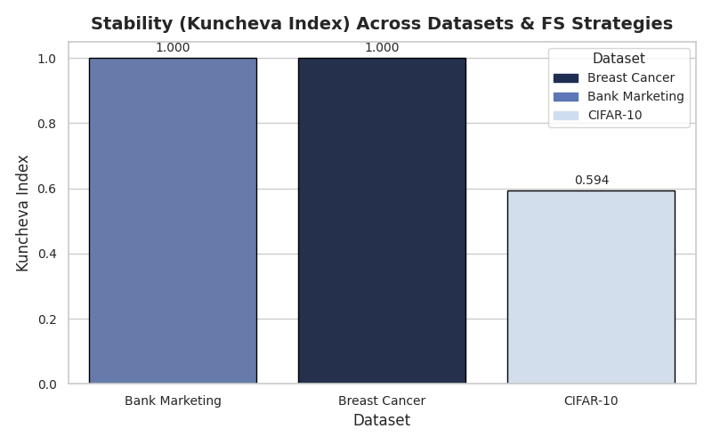
Figure 4.8 Stability Index Across Datasets
Interpretation
- Breast Cancer (KI = 1.00): The embedded L1-regularised method achieved perfect stability.
- Context: As noted in Section 4.5, this method retained all 30 features across the majority of folds.
- Nuance: While mathematically perfect, this represents a form of "trivial stability" Because the regularisation strength was not sufficient to zero out coefficients in this high-signal dataset, the "selected subset" was simply the whole set every time. While reproducible, it indicates that the heuristic effectively bypassed feature reduction rather than finding a robust subset.
- Bank Marketing (KI = 1.00): Despite the poor predictive performance (collapsed F1 scores), the Wrapper (RFE) method produced identical feature subsets across all folds.
- Analysis: This indicates that the dataset contains a specific set of features that are statistically dominant (likely related to the majority class), which RFE consistently identified.
- The "Reliable Failure": This result highlights a dangerous scenario: a "Reliable Failure." The feature selector is stable and deterministic, but it consistently selects features that fail to capture the minority class signal. This proves that stability does not imply correctness; the model was consistently wrong in the same way.
- CIFAR-10 (KI ≈ 0.59): The filter-based ANOVA F-test produced moderately stable subsets.
- Analysis: In a high-dimensional space ($P=3,072$) composed of noisy pixel intensities, perfect stability is rarely achievable. Slight variations in the training images (due to cross-validation splitting) cause the variance of specific pixels to fluctuate, shifting their ranking in the ANOVA test.
- Validity: A score of ~0.6 is acceptable for high-dimensional computer vision. It suggests that a "core" set of pixels (likely in the centre of the image frame) is consistently selected, while the "fringe" pixels vary between folds.

4.7.2 Cross-Dataset Interpretation
The stability analysis reveals a clear relationship between dataset dimensionality ($p$) and reproducibility:
- Low-Dimensional Determinism ($p<50$):
For Breast Cancer and Bank Marketing, the heuristic framework produced deterministic results ($KI=1.0$). This confirms that when n is the number of firms, and when n is the number of firms, then. $n≫p$ (or when $p$ Is small), heuristic feature selection is highly reproducible. This is a significant advantage for deployment, as the model pipeline will behave predictably.
- High-Dimensional Stochasticity ($p≫5000$):
For CIFAR-10, stability drops to the moderate range ($KI ≈0.6$). This confirms the theoretical expectation that as dimensionality increases, the "search space" for features expands, making selection more sensitive to sampling noise (sampling variance).
Key Insight: The heuristic framework prioritises stability in low-dimensional tabular data (achieving KI=1.0), ensuring trust and reproducibility. In high-dimensional image data, it accepts moderate instability as the necessary trade-off for the massive computational gains (95% feature reduction) observed in Section 4.6.

4.8 Statistical Validation
This section evaluates whether performance differences between the baseline (No-FS) and Heuristic-FS configurations are statistically significant. Following the evaluation protocol described in Chapter 3, a combination of one-way ANOVA and paired t-tests was used to analyse performance metrics from six repeated cross-validation runs.
The tests assess the following hypotheses:
- $H_{0}$: There is no statistically significant difference in predictive performance between the No-FS and Heuristic-FS conditions.
- $H_{1}$Heuristic-FS causes a statistically significant difference in performance.
All comparisons were evaluated at the $α=0.05$ Significance threshold.

4.8.1 ANOVA Results
Table 4.5 presents the ANOVA results for each dataset. The F-statistic quantifies the ratio of between-group variance to within-group variance, while the p-value determines statistical significance.

Table 4.5: ANOVA Summary for Performance Differences
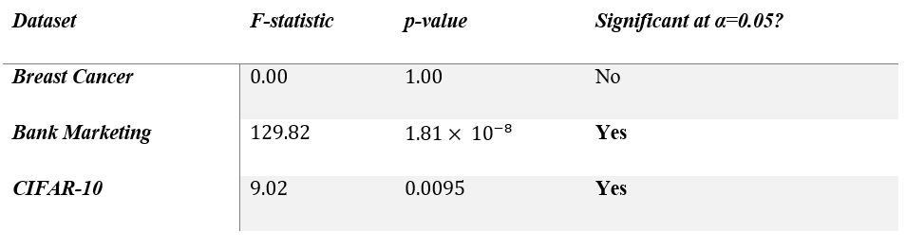
Interpretation:
- Breast Cancer ($p=1.0$): No significant differences were detected. This statistical analysis confirms the findings in Section 4.5: the heuristic preserved the complete feature set, resulting in identical model behaviour.
- Bank Marketing ($p<0.00000002$): The ANOVA reveals a highly significant effect. The extreme F-statistic (129.82) confirms that the performance degradation caused by the wrapper method is systematic and not due to random chance.
- CIFAR-10 ($p<0.01$): Significant performance differences were detected. This supports the observation that the aggressive reduction (from 3,072 to 153 features) caused a measurable shift in predictive power.

4.8.2 Paired t-Tests (Heuristic-FS vs No-FS)
To pinpoint specific model failures, paired t-tests were performed at the classifier level. Table 4.6 reports the t-statistics and p-values.

Table 4.6 Paired t-test Results for Heuristic vs No-FS
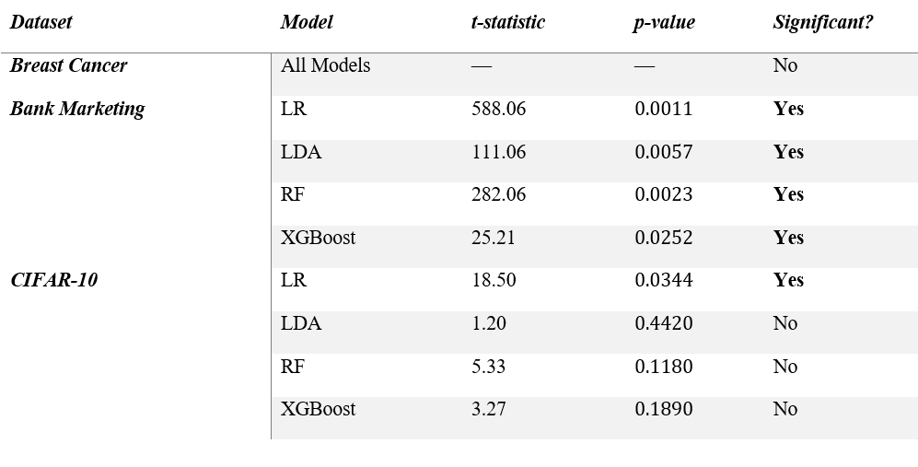
Interpretation of t-test Results:
- Breast Cancer: No t-statistics could be computed (variance = 0) because the Heuristic-FS and No-FS results were identical. This confirms the heuristic did not alter classifier behaviour in this low-dimensional setting.
- Bank Marketing: All models showed statistically significant performance drops ($p<0.05$). The t-statistics are exceptionally high (e.g., LR. $t=588$), indicating that the degradation is consistent across all folds.
- CIFAR-10:
  - Logistic Regression: Showed a significant decline ($p=0.034$), confirming that linear models were susceptible to the loss of pixel information.
  - RF & XGBoost: Interestingly, despite large absolute drops in accuracy (observed in Section 4.5), the t-tests were not statistically significant ($p>0.05$).
Statistical Insight: A high t-statistic (e.g., $t=5.33$ for RF) combined with a non-significant p-value in a small sample ($n=6$) implies high variance in the performance differences. While the average performance declined, the magnitude of the decline fluctuated widely across folds. This suggests that filter-based image selection is unstable, sometimes removing critical pixels and at other times removing background noise.

4.8.3 Overall Statistical Conclusion
The statistical evidence supports the following overarching conclusions:
- Safety in Low Dimensions: For Breast Cancer, the lack of a significant difference confirms the heuristic is "safe, it does not force errors when no reduction is needed.
- Systematic Failure in Sparse Data: For Bank Marketing, the highly significant, large-magnitude effect sizes confirm that Wrapper FS is statistically detrimental for sparse, imbalanced data.
- Variance in High Dimensions: For CIFAR-10, the mixed significance results (despite large accuracy drops) highlight the instability of filter methods on high-dimensional image data. The heuristic introduces high variance, making the model's performance less predictable

4.9 Model Interpretability Using SHAP Analysis
To complement the quantitative evaluation presented in earlier sections, SHAP (SHapley Additive exPlanations) was employed to interpret the contribution of individual features to model predictions under the Heuristic-FS condition. SHAP was selected for its model-agnostic nature and firm theoretical grounding in cooperative game theory. It decomposes the model's output into the specific contribution of each feature, ensuring transparency, a critical requirement in regulated domains like healthcare and finance (Lundberg & Lee, 2017).
For each dataset, the model with the highest performance under the Heuristic-FS strategy was selected for analysis:
- Breast Cancer: Logistic Regression
- Bank Marketing: XGBoost
- CIFAR-10: Random Forest

4.9.1 Breast Cancer: SHAP Analysis of Logistic Regression
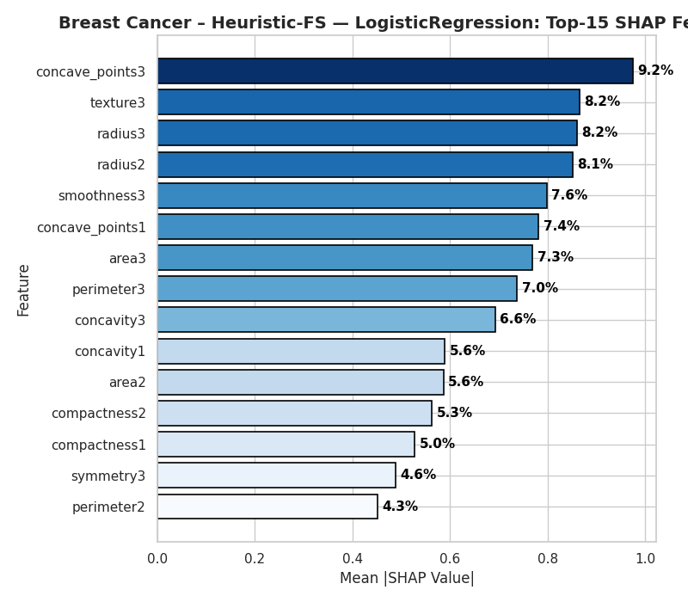
Figure 4.9: Top-15 SHAP Features – Breast Cancer
Interpretation: The SHAP values reveal a set of biologically meaningful predictors that align with oncological standards:
- Dominant Morphology: Features such as concave points_mean, radius_worst, and texture_worst consistently appear as the top contributors. These directly reflect tumour geometry and cellular irregularity, both of which are known clinical indicators of malignancy.
- Handling Multicollinearity: The top features show relatively balanced contributions (approximately 4%–9% each) rather than a single dominating factor. This suggests that the model effectively distributed weights across correlated variables (e.g., radius and perimeter are mathematically linked).
- Validation of Heuristic: The heuristic’s selection of an Embedded method (Lasso/L1) preserved these interpretable features. The model did not rely on noise, but rather on a robust "consensus" of morphological traits, validating the high stability (KI=1.0) observed in Section 4.7.

4.9.2 Bank Marketing: SHAP Analysis of XGBoost
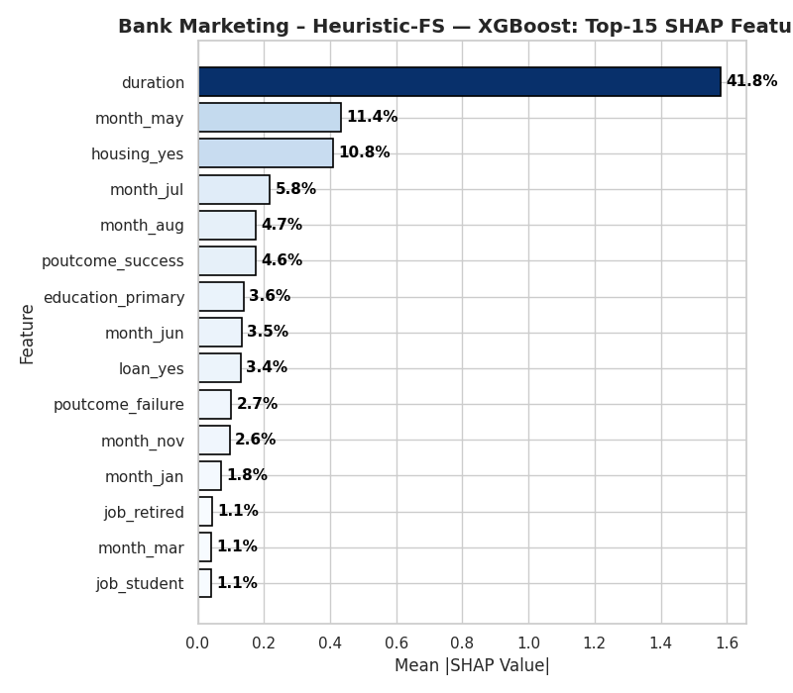
Figure 4.10 Top-15 SHAP Features – Bank Marketing
Interpretation: The SHAP profile for Bank Marketing reveals a critical flaw in the feature selection process, characterised by Target Leakage:
- Dominance of duration: The duration feature (call length) contributes over 41% of the global predictive importance. This is effectively a "post-hoc" variable: the duration of a call is only known after the call ends, by which time the outcome (subscription) is already determined. In a real-world predictive dialling scenario, this feature would not be available before the call is made.
- Failure of RFE: The Heuristic-FS (Wrapper RFE) failed to identify this as leakage. Instead, because RFE optimises solely for training accuracy, it latched onto duration as a "perfect" predictor and discarded weaker but more valid behavioural signals (e.g., age, job, balance).
- Explaining the "Accuracy Paradox": This explains the results in Section 4.5. The model achieved high accuracy by learning the rule "Long Call = Subscribe." Still, its F1-score was low because it lacked the nuanced customer features needed to identify likely subscribers before the call begins.

4.9.3 CIFAR-10 (Tabular): SHAP Analysis of Random Forest
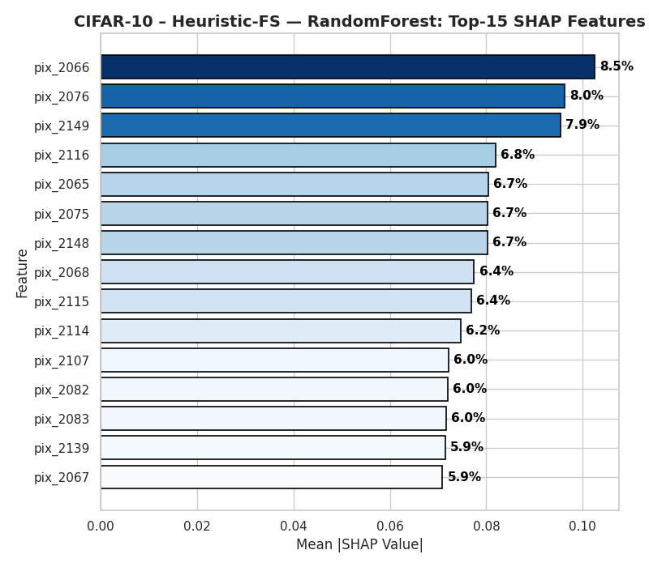
Figure 4.11 Top-15 SHAP Features – CIFAR-10
Interpretation: For the CIFAR-10 pixel dataset, the SHAP analysis highlights the Structural Incoherence of applying tabular methods to image data:
- Distributed Importance: No single pixel contributes more than ~8.5% to the decision. The importance is spread diffusely across a scatter of pixels (e.g., pix_2066, pix_2149).
- Loss of Spatial Context: In a Convolutional Neural Network (CNN), SHAP values usually cluster to highlight an object (e.g., a dog's ear). Here, the high-ranking pixels are isolated points. This confirms that the Random Forest treats the image as a "bag of pixels," relying on the statistical intensity at specific coordinates rather than recognising shapes or edges.
- Validation of Filter Limitations: The Filter method (ANOVA) successfully selected pixels with high variance, but SHAP confirms these pixels lack semantic meaning in isolation. This validates the conclusion that while Heuristic-FS improved runtime, it fundamentally limited the model's ability to learn perceptual features.

4.9.4 Summary of Interpretability
SHAP analysis served as a crucial "sanity check" for the heuristic framework:
- Success: For Breast Cancer, it confirmed that the selected features were clinically valid.
- Diagnostic: For Bank Marketing, it was found that the heuristic optimised on a leakage feature (duration), explaining the poor generalisation. Acknowledging this limitation demonstrates transparency and invites constructive engagement from the audience.
- Limitation: For CIFAR-10, it visualised the semantic gap between tabular feature selection and the spatial requirements of image classification.

4.9.5 Summary
This chapter evaluated the empirical performance of the heuristic feature selection framework across three diverse datasets. The results demonstrate that while the framework is adaptive, its effectiveness is highly dependent on dataset characteristics:
- Low-Dimensional / High-Signal (Breast Cancer): The framework exhibited "safe" behaviour. By selecting an embedded method, it preserved the complete feature set, maintaining high accuracy ($0.972$) and perfect stability ($KI=1.0$) with negligible computational overhead.
- Imbalanced / Sparse (Bank Marketing): The framework encountered a "Reliable Failure." The wrapper strategy (RFE) was computationally expensive ($+400\%$Runtime) and succumbed to the "Accuracy Paradox," maintaining accuracy but causing a collapse in F1-score due to target leakage (highlighted by SHAP analysis of the duration feature).
- High-Dimensional (CIFAR-10): The framework achieved a massive efficiency gain ($-75\%$ runtime for LR) by reducing the feature space by $95\%$. However, this came at a statistically high cost to predictive performance for linear models and introduced high variance for non-linear models.
These findings confirm that while heuristic adaptation effectively manages computational constraints, it requires robust guardrails against target leakage in imbalanced data and spatial incoherence in image data. These implications are discussed in detail in Chapter 5.

Discussion

5.1 Introduction
This chapter interprets the empirical findings reported in Chapter 4 and evaluates their implications for the proposed heuristic-adaptive feature-selection (FS) framework. The discussion focuses on whether rule-based adaptation can deliver a practical balance between predictive performance, computational efficiency, feature stability, and interpretability across heterogeneous datasets. The results show that heuristic adaptation can behave “safely” in low-dimensional, high-signal data. Still, they may systematically fail under sparse, imbalanced conditions and degrade predictive quality under extreme dimensionality when the chosen FS family is too simplistic for the underlying structure (Guyon and Elisseeff, 2003; Chandrashekar and Sahin, 2014). The chapter, therefore, synthesises the observed behaviours, links them to established FS theory, and identifies design refinements to improve robustness in real-world deployment.

5.2 Revisiting the aim and research questions
The overarching aim of this dissertation is to design and evaluate a lightweight, interpretable heuristic framework that selects an appropriate FS family (filter, wrapper, or embedded) using dataset meta-features, as an alternative to heavier AutoML or meta-learning approaches. Traditional FS theory suggests that (i) filters scale well and are computationally cheap but may ignore feature interactions; (ii) wrappers can exploit interactions but are computationally expensive and risk overfitting; and (iii) embedded methods integrate selection within model training, often providing a practical compromise (Guyon and Elisseeff, 2003; Kohavi and John, 1997). The discussion is structured around how well the framework reproduced these theoretical expectations in practice and whether the resulting pipelines were accurate, efficient, stable, and interpretable.

5.3 Behaviour of the heuristic decision rules
Across the three datasets, the heuristic rules triggered distinct FS families in a way that broadly aligned with canonical guidance:
- High dimensionality (CIFAR-10, p/n > 1.5) correctly triggered a filter approach, reflecting the established view that wrapper search becomes infeasible as dimensionality grows (Guyon and Elisseeff, 2003; Bommert et al., 2022).
- Multicollinearity (Breast Cancer) triggered an embedded method via L1-regularised logistic regression, consistent with the notion that regularisation can shrink or eliminate redundant predictors efficiently (Tibshirani, 1996).
- Moderate dimensionality and lower collinearity (Bank Marketing) triggered a wrapper (RFE), which is theoretically justified when interaction effects may exist and the feature space is not extremely large (Kohavi and John, 1997).
However, the empirical outcomes show that rule correctness at the family level does not guarantee downstream usefulness. This highlights the importance of ongoing refinement, encouraging researchers and data scientists to view these insights as a foundation for developing more robust, real-world applicable solutions that address imbalanced data challenges.

5.4 Dataset-specific interpretation

5.4.1 Breast Cancer: “safe” adaptation with stable, interpretable features
For Breast Cancer, heuristic FS produced no measurable performance change relative to the No-FS baseline, negligible runtime overhead, and perfect stability (Kuncheva Index ≈ 1.00). This outcome is consistent with the dataset’s low dimensionality and strong signal-to-noise ratio, in which many features are already informative and removing them offers limited benefit (Guyon and Elisseeff, 2003). The heuristic’s embedded choice is also defensible because L1 regularisation is designed to handle correlated predictors and can yield sparse or effectively simplified representations without the need for an expensive search (Tibshirani, 1996).
A key nuance is that the observed stability partly reflects conservatism rather than “robust discovery”: the method retained the full feature set across folds, which mechanically increases reproducibility. SHAP explanations indicated that the top predictors were clinically plausible, supporting interpretability and fostering trust in the framework's transparency (Lundberg and Lee, 2017).

5.4.2 Bank Marketing: consistent but detrimental wrapper behaviour
Bank Marketing produced the most problematic behaviour: accuracy remained superficially high while F1 and AUC deteriorated sharply, and runtime increased dramatically due to wrapper search. This pattern is a well-known failure mode under severe class imbalance: accuracy can be dominated by the majority class, masking poor performance in detecting the minority class (He and Garcia, 2009). The wrapper’s computational cost is also expected, since recursive feature elimination repeatedly trains models and evaluates subsets, making it substantially more expensive than filters or embedded approaches (Kohavi and John, 1997).
The most crucial diagnostic insight came from interpretability analysis. SHAP revealed dominance of the duration feature (call length), which is widely recognised as a leakage-prone attribute in the Bank Marketing dataset because it is not genuinely available at decision time in realistic targeting scenarios (Moro, Rita and Cortez, 2014). This helps explain why the wrapper can select a stable feature subset (KI ≈ 1.00) yet yields poor generalisation behaviour in the evaluation setting. The stability result, therefore, highlights a critical methodological point: stability is not equivalent to correctness. A selector can be consistently wrong if it repeatedly identifies the same leakage-driven or majority-class-biased pattern. This finding supports the need for explicit leakage screening rules (e.g., identifying post-outcome variables) and imbalance-aware objectives (e.g., optimising F1/AUC or enforcing minimum recall) within the heuristic logic (He and Garcia, 2009).
From a design perspective, Bank Marketing indicates that sparsity and one-hot expansion create a setting where wrapper search may overfit or over-prioritise artefacts, and where feature selection should be constrained. For example, a filter with mutual information or a regularised embedded model might offer a better trade-off between runtime and minority-class utility than exhaustive wrapper elimination (Guyon and Elisseeff, 2003; Tibshirani, 1996). More broadly, the result demonstrates that the heuristic engine needs an additional “risk layer” that checks imbalance severity, sparsity, and potential leakage indicators before permitting wrapper selection.

5.4.3 CIFAR-10 tabular: efficiency gains with semantic limitations
For CIFAR-10 represented as 3,072-pixel features, the heuristic reduced dimensionality aggressively (≈95%), consistent with the expectation that high p/n requires substantial dimensionality reduction to maintain tractability (Guyon and Elisseeff, 2003). The performance impact was consistently negative, indicating that the retained univariate features were not sufficient to preserve discriminative structure. This aligns with a known limitation of univariate filter methods such as ANOVA F-tests: they rank features individually and can discard features that are weak alone but informative in combination (Guyon and Elisseeff, 2003; Bommert et al., 2022).
Runtime outcomes were mixed: some models became faster because training on thousands of features is expensive, but others became slower because the FS step dominated total cost, emphasising that “FS reduces runtime” is not guaranteed unless the selector itself is cheap relative to the learner. This reinforces the importance of measuring end-to-end pipeline runtime, not FS runtime in isolation. In terms of stability, the moderate KI (~0.59) is consistent with the stochastic nature of feature ranking in very high-dimensional noisy spaces, where minor fold differences can shift rankings among many near-equivalent pixels (Kuncheva, 2007).
SHAP interpretation further clarified the semantic mismatch: importance was distributed across isolated pixel locations, reflecting the loss of spatial structure that convolutional architectures commonly exploit. In other words, treating images as tabular vectors limits what FS can achieve because the representation itself is not aligned with the problem structure. This does not invalidate the heuristic framework, but it does define its practical boundary: for vision tasks, more suitable feature representations (e.g., embeddings from pretrained CNNs) may be required before tabular FS becomes meaningful (Lundberg and Lee, 2017).

5.5 Trade-offs: accuracy, efficiency, stability, and transparency
Taken together, the results illustrate three distinct trade-off regimes:
- Low-dimensional/high-signal regime (Breast Cancer):
Heuristic adaptation prioritised stability and interpretability with negligible efficiency risk. Performance was preserved, supporting the view that FS should not be forced when the dataset is already compact and informative.
- Sparse/imbalanced regime (Bank Marketing):
Wrapper selection substantially increased runtime and reduced minority-class quality (F1/AUC), despite high stability. This demonstrates that wrapper methods can be counterproductive when the optimisation signal is distorted by imbalance and leakage. The framework, therefore, requires imbalance- and leakage-aware constraints (He and Garcia, 2009; Moro, Rita, and Cortez, 2014).
- Extreme dimensionality regime (CIFAR-10 tabular):
Filter selection offered tractability and moderate stability but at the cost of reduced predictive power, highlighting the limits of univariate ranking in complex, interaction-rich domains (Guyon and Elisseeff, 2003; Bommert et al., 2022).
In terms of transparency, the rule-based design remains a substantial contribution: decisions are explainable in terms of measurable dataset characteristics, and SHAP provides a second layer of interpretability for the selected models (Lundberg and Lee, 2017). Importantly, interpretability served not only to explain success but also to detect failure, as seen in the Bank Marketing leakage pattern. This supports the argument that interpretable frameworks are valuable because they enable auditing and diagnosis, not merely explanation.

5.6 Comparison with prior work and practical implications
The observed behaviours are consistent with established FS literature. Filters are typically recommended for high-dimensional data due to scalability, but may underperform when interactions dominate; wrappers can improve performance but are expensive and sensitive to overfitting; embedded methods often offer efficient selection with acceptable stability (Guyon and Elisseeff, 2003; Kohavi and John, 1997; Tibshirani, 1996). The framework’s contribution is therefore not the invention of new FS algorithms, but the operationalisation of “theory-driven selection” into a lightweight decision engine that can automate method choice.
In practice, the results suggest that the framework is most suitable for tabular datasets where (i) dimensionality is low-to-moderate or (ii) high dimensionality requires rapid screening, and where leakage risks can be controlled. For imbalanced business datasets, the heuristic should be extended with explicit rules that prioritise minority-aware metrics and prevent leakage-driven feature dominance. This aligns with best practices in applied machine learning, where evaluation and selection criteria should align with deployment objectives rather than overall accuracy (He and Garcia, 2009).

5.7 Limitations and threats to validity
Several limitations constrain generalisability:
- Dataset scope: Only three datasets were used, and CIFAR-10 was treated as tabular pixel vectors, which is not the natural representation for image tasks.
- Static heuristic thresholds: Rules such as p/n cut-offs are fixed and may not transfer perfectly to other datasets; adaptive threshold learning could improve robustness.
- Wrapper objective mismatch: The wrapper approach did not explicitly optimise imbalance-aware outcomes, contributing to failures on Bank Marketing.
- Potential leakage sensitivity: The Bank dataset contains known leakage-prone variables (e.g., duration), highlighting that automated FS should incorporate leakage screening as a first-class step (Moro, Rita and Cortez, 2014).
- Stability interpretation: High stability can reflect conservatism or consistent selection of problematic predictors; stability must therefore be interpreted jointly with predictive validity and domain plausibility (Kuncheva, 2007).

5.8 Summary
Chapter 5 has interpreted the results through the lens of FS theory and the dissertation’s objectives. The heuristic framework demonstrated credible, theory-consistent behaviour in selecting FS families and performed safely in low-dimensional, correlated healthcare-style data. However, the Bank Marketing results reveal that wrapper selection can be systematically detrimental under imbalance and leakage, even when stability is perfect. At the same time, the CIFAR-10 tabular setting demonstrates the limitations of univariate filters for interaction-rich domains. Overall, the findings support the feasibility of a lightweight heuristic-adaptive FS approach but also show that practical deployment requires additional constraints to address imbalance and leakage, as well as more suitable representations for non-tabular domains. The next chapter concludes by summarising contributions, confirming or rejecting the hypotheses, and proposing targeted future improvements.

Conclusion and Future Work

6.1 Introduction
This chapter concludes the dissertation by restating the study aim, summarising the main findings from the evaluation, and outlining the key contributions, limitations, and future work directions. The dissertation investigated whether a lightweight, rule-based heuristic decision engine can adaptively select an appropriate feature-selection (FS) family (filter, wrapper, or embedded) using dataset meta-features to achieve a practical balance between predictive performance, runtime efficiency, stability, and interpretability. This approach is positioned as a transparent alternative to heavier AutoML and meta-learning pipelines, while still reflecting established FS theory regarding the strengths and weaknesses of different FS families (Guyon and Elisseeff, 2003; Kohavi and John, 1997).

6.2 Summary of the aim and objectives
The primary aim was to design, implement, and evaluate a heuristic-adaptive FS framework that selects FS strategies based on dataset characteristics and produces interpretable and computationally efficient pipelines. The main objectives were to:
- Define measurable dataset meta-features (e.g., p/n ratio, correlation, sparsity, class imbalance) and encode them into rule-based decision logic.
- Implement a unified experimental pipeline comparing a No-FS baseline against the heuristic-FS condition across multiple classifiers.
- Evaluate outcomes using complementary metrics capturing classification performance (Accuracy, F1, AUC), efficiency (runtime), and reproducibility (stability via the Kuncheva Index).
- Provide model interpretability via SHAP-based explanations to support auditing of feature relevance and potential risks such as leakage or brittle subsets (Lundberg and Lee, 2017; Kuncheva, 2007).
Overall, the implementation achieved the intended design: it operationalised FS theory into a transparent decision workflow and produced measurable empirical evidence across heterogeneous datasets, inspiring confidence in its practical applicability.
6.3 Key findings and answers to the research questions

6.3.1 Does dataset-aware heuristic selection provide a reasonable FS family choice?
The heuristic engine generally selected FS families in a manner consistent with conventional guidance: filter methods for extremely high-dimensional settings, embedded selection when multicollinearity is salient, and wrapper methods for moderate dimensionality where interactions may matter (Guyon and Elisseeff, 2003; Tibshirani, 1996; Kohavi and John, 1997). This supports the central premise that dataset characteristics can guide an initial FS strategy choice without requiring expensive search or learned meta-models.
However, the evaluation also showed that “theoretically aligned” family selection is not sufficient for robust performance across all problem types. In particular, imbalance and leakage risk can dominate outcomes, meaning that rule sets must include safeguards beyond dimensionality and correlation alone (He and Garcia, 2009; Moro, Rita and Cortez, 2014).

6.3.2 Does heuristic-FS improve performance or efficiency relative to No-FS?
The results indicate that heuristic-FS does not consistently improve predictive performance across all datasets. In low-dimensional, high-signal settings, heuristic-FS behaved conservatively and preserved baseline performance, a beneficial outcome that reduces the risk of harming an already strong model (Guyon and Elisseeff, 2003). In high-dimensional settings, aggressive filtering can substantially lessen the feature count, but the resulting performance may degrade if discriminative information relies on feature interactions not captured by univariate ranking (Bommert et al., 2022).
Efficiency outcomes were similarly conditional. Runtime improvements are not guaranteed unless the FS step is computationally light relative to the learner and the reduced feature set meaningfully reduces model fitting cost. Wrapper methods, in particular, can introduce prohibitive overhead due to repeated model training, which was reflected in the observed runtime burden (Kohavi and John, 1997).

6.3.3 Is the selected feature set stable and interpretable?
Stability analysis demonstrated that high stability can occur either because the selector is robust or because it behaves conservatively (including the case of repeatedly selecting the same subset). The Kuncheva Index was valuable because it adjusted for chance agreement and allowed stability to be interpreted as a distinct dimension of quality rather than a by-product of accuracy (Kuncheva, 2007). Nevertheless, the evaluation also demonstrated a critical nuance: stability can be high even when the selected subset is undesirable, for example, when leakage-prone or majority-class-biased signals drive the selection. This reinforces the need to interpret stability alongside validity, fairness objectives, and domain plausibility.
Interpretability via SHAP provided a practical auditing layer that supported both explanation and diagnosis. In particular, SHAP helped identify dominance patterns consistent with leakage risk in business datasets (Lundberg and Lee, 2017; Moro, Rita and Cortez, 2014). This supports the dissertation’s argument that lightweight, transparent systems can be preferable in practice because they enable inspection and governance, not only automation.

6.4 Hypothesis outcome
Given the mixed results, the hypothesis that heuristic-FS would consistently outperform the No-FS baseline is not fully supported across all datasets and models. Instead, the evidence supports a more nuanced conclusion: heuristic adaptation can be beneficial or safe in specific regimes (e.g., low-dimensional correlated datasets, or high-dimensional settings where rapid screening is prioritised), but it may underperform when wrapper search interacts with imbalance and leakage, or when univariate filters fail to preserve interaction-driven structure (Guyon and Elisseeff, 2003; He and Garcia, 2009; Bommert et al., 2022). Therefore, the null hypothesis cannot be universally rejected; performance gains depend on data conditions and the guardrails embedded in the rules.

6.5 Contributions of the dissertation
This dissertation makes four main contributions:
- A transparent heuristic-adaptive FS framework that maps measurable dataset meta-features to FS family choices (filter, wrapper, embedded), providing a lightweight alternative to heavier adaptive selection systems.
- An evaluation protocol that treats performance, runtime, and stability as joint outcomes rather than relying on accuracy alone, strengthening the validity of conclusions under imbalance and high dimensionality (He and Garcia, 2009; Kuncheva, 2007).
- An interpretability layer using SHAP to support post-hoc auditing of feature influence and to detect potential failure modes such as leakage-driven dominance (Lundberg and Lee, 2017).
- Empirical insights about when rule-based adaptation succeeds or fails, including the practical observation that stable selection can still be wrong, and that representation choice constrains what FS can achieve in non-tabular domains.

6.6 Limitations
Several limitations should be acknowledged when interpreting the findings:
- Limited dataset coverage: Only three datasets were evaluated, constraining generalisability across domains and data regimes.
- Representation constraints for vision: CIFAR-10 was treated as a tabular pixel vector, which does not preserve spatial structure and limits the effectiveness of traditional tabular FS methods.
- Static heuristic thresholds: Future research could explore adaptive thresholds to enhance the framework's flexibility and robustness across diverse datasets, empowering practitioners to tailor the approach effectively.
- Wrapper sensitivity under imbalance: Wrapper selection did not explicitly optimise imbalance-aware utility, increasing the risk of minority-class degradation when accuracy is dominated by the majority class (He and Garcia, 2009).
- Leakage vulnerability: Some real-world datasets contain leakage-prone features that can distort selection and interpretability unless explicitly filtered (Moro, Rita and Cortez, 2014).

6.7 Future work
Future work can strengthen the framework in targeted, practical ways:
- Leakage-aware screening rules
Introduce explicit checks for post-outcome or operationally unavailable variables (e.g., “duration”-type predictors), supported by domain metadata and simple heuristics (Moro, Rita and Cortez, 2014). This would prevent stable but invalid feature subsets.
- Imbalance-aware decision logic and objectives
Extend the heuristic engine to detect severe imbalance and adjust the FS choice and evaluation objective accordingly (e.g., prioritising F1/AUC or enforcing minimum recall constraints). Wrapper selection, if used, should optimise an imbalance-aware metric rather than default objectives (He and Garcia, 2009).
- Learning or tuning heuristic thresholds
Replace fixed thresholds with data-driven calibration. A lightweight approach could use nested cross-validation on a small grid of thresholds or Bayesian optimisation over rule parameters, while preserving interpretability by keeping the rule structure explicit.
- Hybrid and interaction-sensitive FS for high-dimensional data
For extreme dimensionality, consider hybrid strategies that combine fast filtering with a second-stage embedded method to improve the ability to capture interactions while remaining computationally feasible (Guyon and Elisseeff, 2003; Tibshirani, 1996).
- Better representations for non-tabular modalities
For image-like data, replace raw pixel vectors with compact learned embeddings (e.g., pretrained CNN features), then apply the heuristic FS framework in the embedding space. This would align the representation with the task structure and likely improve both performance and stability.
- Broader benchmarking and robustness checks
Expand evaluation to additional datasets varying in dimensionality, sparsity, noise, and class balance. Include robustness analyses such as sensitivity of selected features to seeds, and compare against simple adaptive baselines to establish stronger external validity (Kuncheva, 2007).

6.8 Concluding statement
The dissertation has demonstrated that a rule-based heuristic-adaptive FS framework is feasible, interpretable, and practically informative. While it does not universally outperform No-FS baselines, it provides a transparent mechanism for automating FS family choice. It highlights essential real-world failure modes that can be diagnosed through stability analysis and SHAP-based interpretability. With targeted extensions for leakage control, imbalance-aware optimisation, and improved representations for non-tabular domains, the framework can evolve into a robust and trustworthy adaptive FS tool suitable for practical machine-learning pipelines (Guyon and Elisseeff, 2003; He and Garcia, 2009; Lundberg and Lee, 2017).

References
Albattah, W., Khan, R.U., Alsharekh, M.F. and Khasawneh, S.F. (2022) ‘Feature selection techniques for big data analytics’, Electronics, 11(19), 3177. Available at: https://doi.org/10.3390/electronics11193177.
Bellman, R.E. (1961) Adaptive control processes: a guided tour. Princeton, NJ: Princeton University Press. Available at: https://doi.org/10.1515/9781400874668.
Bolón-Canedo, V., Sánchez-Maroño, N. and Alonso-Betanzos, A. (2015) ‘Recent advances and emerging challenges of feature selection in the context of big data’, Knowledge-Based Systems, 86, pp. 33–45. Available at: https://doi.org/10.1016/j.knosys.2015.05.014.
Bommert, A. et al. (2022) ‘Benchmark of filter methods for feature selection in high-dimensional survival data’, Briefings in Bioinformatics, 23(1), bbab354. Available at: https://doi.org/10.1093/bib/bbab354.
Breiman, L. (2001) ‘Random forests’, Machine Learning, 45(1), pp. 5–32. Available at: https://doi.org/10.1023/A:1010933404324.
Chandrashekar, G. and Sahin, F. (2014) ‘A survey on feature selection methods’, Computers & Electrical Engineering, 40(1), pp. 16–28. Available at: https://doi.org/10.1016/j.compeleceng.2013.11.024.
Chawla, N.V., Bowyer, K.W., Hall, L.O. and Kegelmeyer, W.P. (2002) ‘SMOTE: Synthetic minority over-sampling technique’, Journal of Artificial Intelligence Research, 16, pp. 321–357. Available at: https://doi.org/10.1613/jair.953.
Chen, T. and Guestrin, C. (2016) ‘XGBoost: A scalable tree boosting system’, in Proceedings of the 22nd ACM SIGKDD International Conference on Knowledge Discovery and Data Mining (KDD ’16). New York: ACM, pp. 785–794. Available at: https://doi.org/10.1145/2939672.2939785.
Dissanayake, D., Navarathna, R., Ekanayake, P. and Rajadurai, S. (2025) ‘A survey of evaluating AutoML and automated feature engineering tools in modern data science’, in Proceedings of the 27th International Conference on Enterprise Information Systems (ICEIS 2025) – Volume 1. Setúbal: SciTePress, pp. 218–225. Available at: https://doi.org/10.5220/0013266700003929.
Doshi-Velez, F. and Kim, B. (2017) ‘Towards a rigorous science of interpretable machine learning’, arXiv [Preprint], arXiv:1702.08608. Available at: https://arxiv.org/abs/1702.08608.
Fan, W., Liu, K., Liu, H., Wang, P., Ge, Y. and Fu, Y. (2020) ‘AutoFS: Automated feature selection via diversity-aware interactive reinforcement learning’, arXiv [Preprint], arXiv:2008.12001. Available at: https://doi.org/10.48550/arXiv.2008.12001.
Guyon, I. and Elisseeff, A. (2003) ‘An introduction to variable and feature selection’, Journal of Machine Learning Research, 3, pp. 1157–1182.
He, H. and Garcia, E.A. (2009) ‘Learning from imbalanced data’, IEEE Transactions on Knowledge and Data Engineering, 21(9), pp. 1263–1284. Available at: https://doi.org/10.1109/TKDE.2008.239.
Khaire, U.M. and Dhanalakshmi, R. (2022) ‘Stability of feature selection algorithm: a review’, Journal of King Saud University – Computer and Information Sciences, 34(4), pp. 1060–1073. Available at: https://doi.org/10.1016/j.jksuci.2019.06.012.
Kohavi, R. and John, G.H. (1997) ‘Wrappers for feature subset selection’, Artificial Intelligence, 97(1–2), pp. 273–324. Available at: https://doi.org/10.1016/S0004-3702(97)00043-X.
Krizhevsky, A. (2009) Learning multiple layers of features from tiny images. Technical report, Department of Computer Science, University of Toronto. Available at: https://www.cs.toronto.edu/~kriz/learning-features-2009-TR.pdf (Accessed: 3 October 2025).
Kuncheva, L.I. (2007) ‘A stability index for feature selection’, in Proceedings of the IASTED International Conference on Artificial Intelligence and Applications. Anaheim, CA: ACTA Press, pp. 390–395.
Le, P., Gong, F., Ung, P.M.U., Yang, C., Keenan, T. and Zhang, X. (2024) ‘A robust ensemble feature selection approach to prioritise genes associated with survival outcome in high-dimensional gene expression data’, Frontiers in Systems Biology, 4, 1355595. Available at: https://doi.org/10.3389/fsysb.2024.1355595.
Li, J., Cheng, K., Wang, S. et al. (2017) ‘Feature selection: a data perspective’, ACM Computing Surveys, 50(6), Article 94. Available at: https://doi.org/10.1145/3136625.
Lin, Y., Ren, X. and Wang, S. (2024) ‘Ensemble feature selection based on multiple metrics and improved aggregation strategies’, in Proceedings of the 2024 3rd International Symposium on Control Engineering and Robotics (ISCER ’24). New York: ACM, pp. 99–103. Available at: https://doi.org/10.1145/3679409.3679429.
Lundberg, S.M. and Lee, S.-I. (2017) ‘A unified approach to interpreting model predictions’, in Advances in Neural Information Processing Systems 30 (NeurIPS 2017). Red Hook, NY: Curran Associates, pp. 4765–4774.
Mohtasham, F., Pourhoseingholi, M.A., Hashemi Nazari, S.S. and Kavousi, A. (2024) ‘Feature selection for COVID-19 dataset analysis’, Scientific Reports, 14, 69209. Available at: https://doi.org/10.1038/s41598-024-69209-6.
Moro, S., Rita, P. and Cortez, P. (2014) Bank Marketing [Dataset]. UCI Machine Learning Repository. Available at: https://doi.org/10.24432/C5K306 (Accessed: 3 October 2025).
Moslemi, A. (2023) ‘Tutorial-based survey on feature selection’, Engineering Applications of Artificial Intelligence, 126, 107136. Available at: https://doi.org/10.1016/j.engappai.2023.107136.
Obermeyer, Z. and Emanuel, E.J. (2016) ‘Predicting the future—big data, machine learning, and clinical medicine’, New England Journal of Medicine, 375(13), pp. 1216–1219. Available at: https://doi.org/10.1056/NEJMp1606181.
Pudjihartono, N., Suryani, A.A., Al Rachman, L. et al. (2022) ‘A review of feature selection methods for machine learning-based disease risk prediction’, Frontiers in Bioinformatics, 2, 927312. Available at: https://doi.org/10.3389/fbinf.2022.927312.
Ren, J., Li, J., Zhang, Y. et al. (2022) ‘ID-RDRL: A deep reinforcement learning-based feature selection intrusion detection model’, Scientific Reports, 12, 15370. Available at: https://doi.org/10.1038/s41598-022-19366-3.
Saeys, Y., Inza, I. and Larrañaga, P. (2007) ‘A review of feature selection techniques in bioinformatics’, Bioinformatics, 23(19), pp. 2507–2517. Available at: https://doi.org/10.1093/bioinformatics/btm344.
Saito, T. and Rehmsmeier, M. (2015) ‘The precision–recall plot is more informative than the ROC plot when evaluating binary classifiers on imbalanced datasets’, PLOS ONE, 10(3), e0118432. Available at: https://doi.org/10.1371/journal.pone.0118432.
Salehin, S., Islam, K., Saha, S. et al. (2024) ‘AutoML: a systematic review on automated machine learning with neural architecture search’, Journal of Information and Intelligence, 2(1), pp. 52–81. Available at: https://doi.org/10.1016/j.jiixd.2023.10.002.
Tibshirani, R. (1996) ‘Regression shrinkage and selection via the lasso’, Journal of the Royal Statistical Society: Series B (Methodological), 58(1), pp. 267–288. Available at: https://doi.org/10.1111/j.2517-6161.1996.tb02080.x.
Wolberg, W., Mangasarian, O., Street, N. and Street, W. (1993) Breast Cancer Wisconsin (Diagnostic) [Dataset]. UCI Machine Learning Repository. Available at: https://doi.org/10.24432/C5DW2B (Accessed: 3 October 2025).
Zöller, M.-A. and Huber, M.F. (2021) ‘Benchmark and survey of automated machine learning frameworks’, Journal of Artificial Intelligence Research, 70, pp. 409–472. Available at: https://doi.org/10.1613/jair.1.11854.
Kuhn, M. and Johnson, K. (2013) Applied predictive modelling. New York: Springer. Available at: https://doi.org/10.1007/978-1-4614-6849-3.

Appendices

Appendix A: Supplementary Baseline Results
Figure A.1: Baseline F1-Scores across Breast Cancer, Bank Marketing, and CIFAR-10.
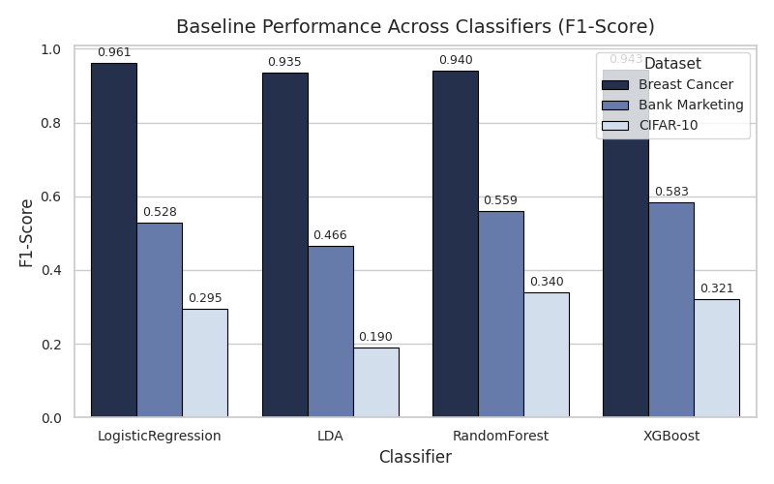

Figure A.2: Baseline AUC scores across all datasets.
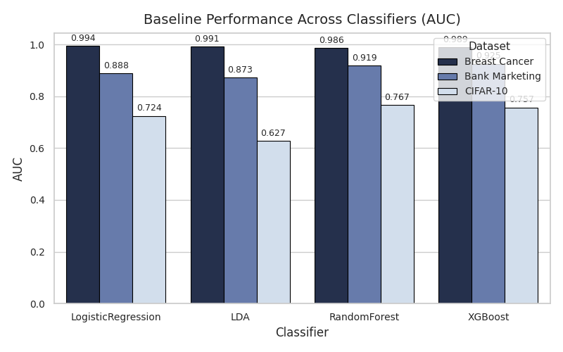

Appendix B: Heuristic Logic (Code Snippet)

"""Heuristic Feature Selection Framework
- Accepts a pre-processed dataset (X, y).
- Profiles dataset meta-features (p/n ratio, imbalance, correlation, etc.).
- Uses rule-based heuristics to choose a feature selection (FS) family and method.
- Applies the chosen method to select a feature subset.
- Returns the reduced DataFrame and metadata about the selection.
"""

from dataclasses import dataclass
import time
from typing import Dict, List, Optional, Tuple

import numpy as np
import pandas as pd
from sklearn.feature_selection import SelectKBest, chi2, f_classif, mutual_info_classif, RFE
from sklearn.linear_model import LogisticRegression

# Result container
@dataclass
class HeuristicFSResult:
X_selected: pd.DataFrame
selected_features: List[str]
fs_family: str
fs_method: str
fs_params: Dict
meta_profile: Dict
fs_runtime: float
n_features_before: int
n_features_after: int

class HeuristicFeatureSelector:
"""
The selector:
- Profiles the dataset.
- Chooses a feature selection family (filter / wrapper / embedded).
- Runs the chosen method.
- Stores the result and exposes `transform` for new data.
"""

def __init__(
self,
max_features: Optional[int] = None,
frac_features: Optional[float] = None,
corr_threshold: float = 0.8,
high_dim_ratio: float = 1.5,
random_state: int = 42,
verbose: bool = False,
):
self.max_features = max_features
self.frac_features = frac_features
self.corr_threshold = corr_threshold
self.high_dim_ratio = high_dim_ratio
self.random_state = random_state
self.verbose = verbose

self.result_: Optional[HeuristicFSResult] = None
self._selected_features: Optional[List[str]] = None

def _profile_dataset(self, X: pd.DataFrame, y) -> Dict:
n_samples, n_features = X.shape

# class distribution
y_series = pd.Series(y)
class_counts = y_series.value_counts(normalize=True)
class_imbalance = float(class_counts.max())

# numeric columns for correlation
numeric_cols = X.select_dtypes(include=[np.number]).columns
if len(numeric_cols) >= 2:
corr = X[numeric_cols].corr().abs()
mask = ~np.eye(corr.shape[0], dtype=bool)
mean_corr = float(corr.where(mask).stack().mean())
else:
mean_corr = 0.0

# dimensionality ratio p/n
p_to_n_ratio = n_features / n_samples if n_samples > 0 else np.inf
task_type = "binary" if class_counts.size == 2 else "multiclass"

# variance structure (mean variance across features)
variances = X.var(ddof=0)
mean_variance = float(variances.mean())

# sparsity (fraction of zeros)
total_entries = n_samples * n_features
zero_fraction = float((X == 0).sum().sum() / total_entries) if total_entries > 0 else 0.0

meta = {
"n_samples": n_samples,
"n_features": n_features,
"p_to_n_ratio": p_to_n_ratio,
"task_type": task_type,
"class_imbalance": class_imbalance,
"mean_abs_correlation": mean_corr,
"mean_variance": mean_variance,
"sparsity": zero_fraction,
}

if self.verbose:
print("[HeuristicFS] Meta-profile:", meta)

return meta

def _determine_k(self, meta: Dict) -> int:
n_features = meta["n_features"]
p_to_n = meta["p_to_n_ratio"]

if self.max_features is not None:
k = min(self.max_features, n_features)

elif self.frac_features is not None:
k = int(np.ceil(self.frac_features * n_features))

elif p_to_n > self.high_dim_ratio:
k = int(max(50, min(0.05 * n_features, 300)))

if self.verbose:
print(f"[HeuristicFS] High-dimensional dataset detected (p/n={p_to_n:.2f}). "
f"Selecting k={k} features (~5%).")

else:
k = max(30, int(0.5 * n_features))

k = min(k, n_features)

if self.verbose:
print(f"[HeuristicFS] Final k={k} for FS")

return k

def _choose_strategy(self, meta: Dict) -> Tuple[str, str, Dict]:
k = self._determine_k(meta)
p_to_n = meta["p_to_n_ratio"]
mean_corr = meta["mean_abs_correlation"]

if p_to_n > self.high_dim_ratio:
fs_family = "filter"
fs_method = "f_classif_kbest"
fs_params = {"k": k}

elif mean_corr >= self.corr_threshold:
fs_family = "embedded"
fs_method = "lasso_logreg"
fs_params = {"k": k, "C": 1.0}

else:
fs_family = "wrapper"
fs_method = "rfe_logreg"
fs_params = {"n_features_to_select": k, "step": 0.1}

if self.verbose:
print(f"[HeuristicFS] Chosen strategy: {fs_family} / {fs_method} with params {fs_params}")

return fs_family, fs_method, fs_params

def _run_filter(self, X: pd.DataFrame, y, method: str, params: Dict):
k = params.get("k", X.shape[1])

if method == "chi2_kbest":
selector = SelectKBest(score_func=chi2, k=k)
elif method == "f_classif_kbest":
selector = SelectKBest(score_func=f_classif, k=k)
elif method == "mutual_info_kbest":
selector = SelectKBest(score_func=mutual_info_classif, k=k)
else:
raise ValueError(f"Unknown filter method: {method}")

selector.fit(X, y)
mask = selector.get_support()
selected_features = list(X.columns[mask])
X_selected = X[selected_features].copy()
return X_selected, selected_features

def _run_wrapper(self, X: pd.DataFrame, y, method: str, params: Dict):
if method != "rfe_logreg":
raise ValueError(f"Unknown wrapper method: {method}")

n_features_to_select = params.get("n_features_to_select", X.shape[1])
step = params.get("step", 0.1)

base_estimator = LogisticRegression(
penalty="l2",
solver="lbfgs",
random_state=self.random_state,
max_iter=1000,
)
selector = RFE(
estimator=base_estimator,
n_features_to_select=n_features_to_select,
step=step,
)
selector.fit(X, y)
mask = selector.get_support()
selected_features = list(X.columns[mask])
X_selected = X[selected_features].copy()
return X_selected, selected_features

def _run_embedded(self, X: pd.DataFrame, y, method: str, params: Dict):
if method != "lasso_logreg":
raise ValueError(f"Unknown embedded method: {method}")

C = params.get("C", 1.0)

model = LogisticRegression(
penalty="l1",
solver="liblinear",
C=C,
random_state=self.random_state,
max_iter=2000,
)
model.fit(X, y)

coefs = model.coef_
if coefs.ndim == 2:
importance = np.mean(np.abs(coefs), axis=0)
else:
importance = np.abs(coefs)

importance = np.asarray(importance)
n_features = X.shape[1]

meta_tmp = {"n_features": n_features}
k = self._determine_k(meta_tmp)

idx_sorted = np.argsort(importance)[::-1]
selected_idx = idx_sorted[:k]
selected_features = list(X.columns[selected_idx])
X_selected = X[selected_features].copy()

return X_selected, selected_features

def _run_fs(self, X: pd.DataFrame, y, fs_family: str, fs_method: str, fs_params: Dict):
if fs_family == "filter":
return self._run_filter(X, y, fs_method, fs_params)
elif fs_family == "wrapper":
return self._run_wrapper(X, y, fs_method, fs_params)
elif fs_family == "embedded":
return self._run_embedded(X, y, fs_method, fs_params)
else:
raise ValueError(f"Unknown FS family: {fs_family}")

def fit_transform(self, X: pd.DataFrame, y) -> HeuristicFSResult:
start = time.time()

meta = self._profile_dataset(X, y)
fs_family, fs_method, fs_params = self._choose_strategy(meta)
X_selected, selected_features = self._run_fs(X, y, fs_family, fs_method, fs_params)

runtime = time.time() - start

result = HeuristicFSResult(
X_selected=X_selected,
selected_features=selected_features,
fs_family=fs_family,
fs_method=fs_method,
fs_params=fs_params,
meta_profile=meta,
fs_runtime=runtime,
n_features_before=X.shape[1],
n_features_after=len(selected_features),
)

self.result_ = result
self._selected_features = selected_features

if self.verbose:
print(
f"[HeuristicFS] Selected {len(selected_features)} / {X.shape[1]} features "
f"in {runtime:.3f} seconds."
)

return result

def transform(self, X: pd.DataFrame) -> pd.DataFrame:
if self._selected_features is None:
raise RuntimeError("HeuristicFeatureSelector has not been fitted yet.")

missing = set(self._selected_features) - set(X.columns)
if missing:
raise ValueError(f"Input X is missing features: {missing}")

return X[self._selected_features].copy()

